**Traffic Management System**

Group Name: Spartans



|  |  |
| --- | --- |
| **Registration No** | **Name with Initials** |
| 154006D | M.K.M.A.Arshan |
| 154007G | M.M.F.Arzana |
| 154203E | A.F.Rifaza |

Faculty of Information Technology

University of Moratuwa

March 2020

**Traffic Management System**

Group Name: Spartans

Final Report

|  |  |
| --- | --- |
| **Registration No** | **Name with Initials** |
| 154006D | M.K.M.A.Arshan |
| 154007G | M.M.F.Arzana |
| 154203E | A.F.Rifaza |

Supervised By:

**Mr. MFM Firdhous**

Dissertation submitted to the Faculty of Information Technology, University of Moratuwa, Sri Lanka for the partial fulfillment of the requirements of the Honours Degree of Bachelor of Science in Information Technology.

**March 2020**

**Declaration**

We declare that this thesis is our own work and has not been submitted in any form for another degree or diploma at any university or other institution of tertiary education. Information derived from the published or unpublished work of others has been acknowledged in the text and a list of references is given.

Name of the student Signature of student

M.K.M.A. Arshan ……………………

M.M.F. Arzana …………………….

A.F. Rifaza …………………….

Date: ……………….

Name of supervisor Signature of supervisor

Mr. MFM Firdhous ………………………..

Date: …………………..

**Acknowledgment**

We extend our sincere gratitude to those who helped us make this project a success with all the guidance and advice.

We thank our project supervisor first, Senior Lecturer Mr.MFM Firdhous for his right guidance, suggestions, encouragement and the opportunity given for us to handle the project and all the support extended us so far. His good advice was a great inspiration.

A word of appreciation goes to the Lecturer committee of the Faculty of Information Technology, for giving us advices and guidance on different areas that are related to the project and to design and fine tune our final solution. Further, we would like to thank all the Instructors, other staff members of the faculty, who helped us in many ways to make this project a reality.

Heartiest thanks for our parents, friends and siblings for always cheering up and help us, standing by us through the good times and bad. Finally we would like to thank all the people who we couldn’t mention above and the people who made us up by even a single word.

**Abstract**

In the current world air pollution become the most serious problem for all life forms and the whole ecosystem. The effect of air pollution varies from respirational infection to global warming. According to WHO statistical records, seven million humans die worldwide each year due to the air pollution. Road traffic constitutes a significant amount of air pollution in the urban cities and the number of increases in the vehicle became a threat to maintain the traffic. This research provides a way to reduce air pollution through control the traffic in certain places. For this experiment, three kinds of places choose as follows: Hospitals, Schools, and Normal Areas. This research has 3 modules as follows :( 1) Predict the AQHI and predict the health level of AQHI (2) Finding the optimized route (3) Future simulation prediction. In this project we used two models to predict the AQHI and AQHI level according to the accuracy, system was implemented by using the Deep Neural network and Decision Tree.

Key words: Air pollution, Ecosystem, Air Quality Health Index, Deep Neural Network, Air Quality Health Index Level, Pollutants, Air quality

Table of Content

Chapter 1 1

1.1 Background and Motivation 1

1.2 Problem in Brief 2

1.3 Aim and Objectives 2

1.3.1 Aim 2

1.3.2 Objectives 2

1.4 Proposed solution in Brief 3

1.5 Summary 3

Chapter 2 4

2.1 Introduction 4

2.2 Review of others’ Work 4

2.2.1 Air Quality Index and Air Pollutant Concentration Prediction Based on Machine Learning Algorithms 4

2.2.2 Air quality forecasting based on cloud model granulation 6

2.3 Summary 10

Chapter 3 11

3.1 Introduction 11

3.2 Required Technologies 11

3.2.1 Python 11

3.2.2 ANN 11

3.2.3 Arc Map 11

3.2.4 PostgreSQL 11

3.2.5 Tensor Flow 12

3.2.6 SKLearn 12

3.2.7 PostGIS 12

3.2.8 GeoDjango 12

3.3 Summary 12

Chapter 4 13

4.1 Introduction 13

4.2 Project Approach 13

4.2.1 System 13

4.2.2 Users 17

4.2.3 Inputs 17

4.2.4 Process 18

4.2.5 Outputs 18

4.3 Summary 19

Chapter 5 20

5.1 Introduction 20

5.2 Architecture of System 20

5.2.1 High level architecture of overall system 21

5.2.2 High level architecture of individual module 22

5.3 Summary 35

Chapter 6 35

6.2 Introduction 35

6.3 Predicting the AQHI and AQHI level 36

6.3.1 Preprocessing Module 36

6.3.2 Predicting the AQHI 36

6.3.3 Predicting the AQI Health level 40

6.4 Finding the optimal direction 43

6.4.1 Creating the customized map 47

6.5 Future simulation prediction 48

6.6 Summary 50

Chapter 7 51

7.1 Introduction 51

7.2 Evaluation Methods and Results 51

7.2.1 AQI prediction models 51

7.2.2 Predicting AQI Health level model evaluation 53

7.2.3 Identifying Optimized path module evaluation 55

7.2.4 Future simulation prediction module evaluation 55

7.3 Summary 56

Chapter 8 57

8.1 Introduction 57

8.2 Discussion about the work 57

8.3 Limitations and Further Work 57

8.4 Conclusion 57

8.5 Summary 58

Chapter 9 58

## 

**Table of Figure**

Figure 5.1: High Level Architecture of the System 22

Figure 5.2 : View of AQI calculator on EPA website 23

Figure 5.3: View of AQI calculator on EPA website 24

Figure 5.4 : View of Dataset 25

Figure 5.5: Confusion matrix 26

Figure 5.6 :Confusion matrix 27

Figure 5.7 : Machine Learning Process 28

Figure 5.8: Over all process of predicting AQHI 29

Figure 6.1 : Correlation Matrix 37

Figure 6.2 : The layer of the system 38

Figure 6.3: View of loss value for checkpoint 38

Figure 6.4: The best loss value for checkpoint 39

Figure 6.5 the absolute error of the random forest 39

Figure 6.6 Shows the details of connected road 40

Figure 6.7 : The details of places in the connected road 41

Figure 6.8 : The details of the places 41

Figure 6.9 : The predicted AQHI health level of the places 42

Figure 6.10: The relevant details of the certain place 43

Figure 6.11: The AQHI and distance shorting 44

Figure 6.12: The shorting results and next location 45

Figure 6.13: The selected road id 46

Figure 6.14 : The coordination for the path 46

Figure 6.15 : The selected path 47

Figure 6.16 : The map of UOM 48

Figure 6.17 : The AQHI changing rate for the day 49

Figure 6.18 :The forecasted health level 50

Figure 7.1:The mean squared error rate 52

Figure 7.2:Validation of random forest 52

Figure 7.3: validation 54

**List of Tables**

Table 4.1:Guidance for air quality Index 15

Table 4.2: Standard level for AQI 16

Table 4.3:AQI health level Vs. Consequence 17

Table 4.4:Input table 18

Table 4.5:Views of Output table 19

Table 5.1:Break point for AQI 30

Table 7.1:The evaluation details of AQHI prediction module 51

Table 7.2:Evaluation details of AQHI health level predication module 53

Table 7.3:The evaluation details of optimized path module 55

Table 7.4:The details of future simulation module 55

# 

**Introduction**

In now a days, traffic management has become one of the key concerns for the urban city. The continuous increase in the number of vehicles has led to the continuing problem of traffic management. Countries around the world expect to develop efficient traffic management systems by using ICT technologies. The recent development of Wireless Sensor Network [WSN] and low cost power consuming sensors dominate towards creating an intelligent traffic management system [13]. ICT provides solution which includes traffic control, traffic prediction, traffic detection and traffic management. Among them short term traffic flow prediction is key, especially in a Dynamic Traffic Management [DTM] system. Recent years many different short-term traffic flow predication methods have been proposed. The studied prediction methods can be generally classified into traditional predication and intelligent method. Traditional prediction method includes Markov, Poisson, ARMA, etc. but they based on linear methods. Liner method is unable to accurately depict these features of traffic flow. So the ideal result is difficult to get in the traditional prediction method. With the rapid development of the traffic scale, traffic has presented complex, nonlinear and time varying feature. The intelligent prediction method includes Deep Neural Network method, Fuzzy control method, Genetic Algorithm [GA], Particle Swarm Optimization [PSO], etc. In intelligent prediction method, the Deep Neural Network Method has powerful learning ability and describing ability of nonlinear relationship between the various factors, because of that here we used Deep Neural Network for predicting short term traffic flow for users in different environments [11]

## Background and Motivation

Air pollution has become a major issue in the recent decades and it has serious toxicological impact on environment and man health. The source of pollutions varies from small cigarettes up to large volcanic eruption, forest fire, industrial activities and large amount of emission from vehicle engines. Long inhalation of polluted air can cause respiratory infection and inflammations, cancer, cardiovascular dysfunctions and millions of death worldwide each year and also air pollution cause to acid rain and Green house effects which affect the whole ecosystem. In recent research World Health Organization [WHO] have been released that Sulfur oxides, CO, Particle pollution, nitrogen oxides, ground level O3 and lead [Pb] are the main air pollutants which harm to human health and ecosystem. According to WHO statistic records seven million people are die worldwide each year [24]. High concentration of dust, smokes, gaseous pollutants, fumes, mists, polycyclic aromatic hydrocarbons [PAHs], halogen derivatives and Volatile organic compounds [VOCs] cause vulnerability to many types of cancers [4].

In the developing countries, industrial activities and emission of inappropriate vehicle engines are the main reason to the air pollution. Traffic and transport, mainly motor vehicles cause lots of detrimental impact on the health and environment [12].

## Problem in Brief

In the current world, the environmental pollution specially, air pollution has become a serious problem facing humanity and other life form. Road traffic constitutes a large amount of air pollution in towns and cities and it is causing serious pollution problems and also its harm to human being and other life form. With the increasing number of private vehicles, road traffic becomes a problem to pure air in the industrialized nations. Vehicle fumes release harmful chemicals which pollute the atmosphere and it produces greenhouse gases which cause to global warming, climate change, resource depletion and hazardous waste [11]. Pollution disturbs our balance of ecosystem and balance of the environment which brings about changes that affect normal lifestyles of humans and other life forms on our planet today [25]. Especially, school children, pregnant ladies and elders are affected by this air pollution easily because they have less amount of immunity compare to other aged peopled. While there are many ways for the government to reduce pollution, such as traffic regulation and vehicle status, it is not enough to accommodate the growing number of vehicles. Hereby we propose systems which reduce the air pollution by navigating the vehicle to other route away from high traffic area. In this research purpose our target of interest are school children and hospitalized patients. By navigating the vehicle away from schools and hospitals region we can be able to maintain the air quality of above surrounding areas.

## Aim and Objectives

### Aim

Develop a traffic management system to provide the suggestion automatically for to continue the particular route or navigate another route based on different features of the environment.

### Objectives

* Identifying the health risk of air pollution
* Identifying the relationship between traffic conjunction and air pollution
* Identifying and analyzing different features of the environment that are mostly related to the traffic.
* Identifying and analyzing relationship between that features and AQI, AQHI.
* Identifying and analyzing relationship between the AQHI and AQHI level
* Analyzing AQHI with air pollution
* Getting the data near the hospital, school and normal region places.
* Finding the optimized path and generating the suggestion
* Simulating the future prediction

## Proposed solution in Brief

In this section, we discuss the proposed solution to the above-addressed problem brief. We have proposed a system that automatically suggests an optimum route to vehicle drivers based on the different environmental factors. In this research, our targets of aim are school children and patients who hospitalized. By navigating the vehicle away from schools and hospitals region we can able to maintain the air quality of the above surrounding.

We get the concentration of the place and predict the AQHI and AQHI level. We suggest the route to the user by considering the AQHI level in different root. In our project we have three modules as follows: AQHI and AQI Health level prediction, Finding the optimized route and Future simulation. Before taking the route commuters can get the knowledge of next hour AQHI health level of the certain place.

## Summary

This chapter discussed about introduction, the problem we are addressing, background details of the problem, aim and objectives of the project and finally proposed solution for identified problems. Rest of the parts in this report are organized follows as. Chapter 2 reviews others literatures, Chapter 3 describes the technologies which we used in this project, Chapter 4 describes our approach towards addressing the identified problem, Chapter 5 includes details about the analysis and design of the project, Chapter 6 describes the implementation related to the project, chapter 7 describe the evaluation of our projects and finally as the conclusion to the report discussion section describes the summary of the report and also the further work that can be done for future research purpose.

# 

**Review of others’ Work**

## Introduction

This chapter the approaches that addressed the same problem of the given project and how those issues can be given a solution is discussed by analyzing the similar approaches of the research area.

## Review of others’ Work

### Air Quality Index and Air Pollutant Concentration Prediction Based on Machine Learning Algorithms

Air pollution is one most serious environmental issue in current world. We can protect people from Sevier diseases and controlling the air pollution through forecasting the air quality of the air. For that in this work they used Random Forest regression [RFR] and Support vector Regression [SVR] models to predict the Air Quality Index [AQI] in Beijing and the concentration of nitrogen oxide in an Italian city using different two dataset which are publicly provided. Here they used AQI according to the Chinese Standard GB3095-2012 to predict the air quality and the calculated using 6 important pollutants. They are Ozone [O3], Particular matter [PM25], inhalable particles [PM10], sulfur dioxide [SO2], nitrogen dioxide [NO2] and carbon monoxide [CO] [7, 18, and 23]. AQI measure scale range from 0 to 500 which is categorized into 6 levels [good, moderate, lightly polluted, moderately polluted, heavily polluted and severely polluted [27].

To forecasting the Air quality, they very first found the correlation of different air indicators, like concentration of NO2, PM25, and PM10 so on. After that they use random forest regression models and support vector regression to predict the AQI and finally, used RMSE, coefficient determination R² and correlation coefficient r to assessment of appropriateness of regression models [18]. For this they used two sets of different data. First dataset is from Beijing Municipal Environmental Monitoring Center. It is an Air Quality Dataset and it has 1738 records and each included AQI and the concentration of PM25, PM10, NO2, SO2 and O3 based on hourly averaged gave by certified analyzer [5]. As second dataset from air quality recording that contains the response of a gas multi-sensor device deployed on a field in an Italian city [8-10]. It contains 9358 records which hourly averaged. The data obtained for one year. It included concentration for CO, benzene, NOx, non-methane hydrocarbon and NO2. They mainly focus was prediction of NOx because NOx is main factor which helps to identify the quality of the air. Acid rain, ozone destruction and photochemical smog are linked with the NOx emission.

**Air Quality Index prediction of Beijing**

The aim of this experiment was finding the AQI of Beijing and they used first four years of data records to train the model and last year data record for test purpose. For SVR modeling they choose radial basis function (RBF) as the kernel function. Using the grid search method the selected the kernel parameter gamma ($γ$) and penalty parameter (C). C = 10, $γ=0.1$ was selected as a perfect combination from the experiment results for SVR model to predict the AQI. Following were statistical parameter set for testing: r = 0.9887, $R^{2}=0.9776$ and RMSE = 7.666. From the results of experiment finally they came up that SVR model was good to analyzing the regression of AQI.

In the Random Forest model, they used 100 regression trees to construct the regression model to predict the nitrogen oxide concentration. As statistical parameters for RFR model the used as follows: r = 0.9823, RMSE = 9.602 and $R^{2}=0.9633$.

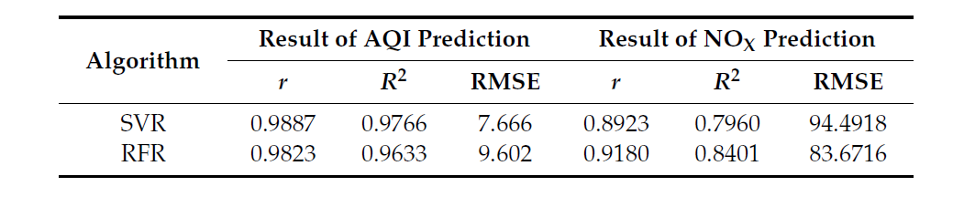

Figure 2.1: Statistical parameters for experiments for AQI and total nitrogen oxide prediction.

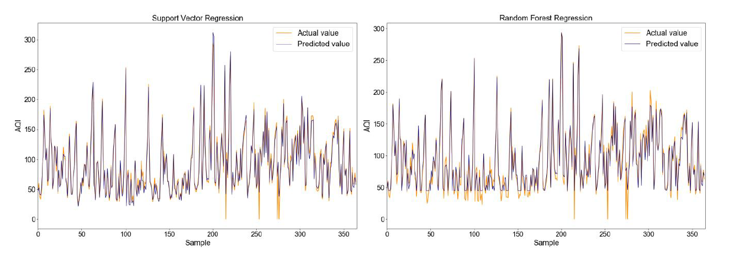

Figure 2.2: Sample testing line chart

Figure 6 shows, x – axis refer the sequence number of the testing samples and y – axis denoting the AQI of Beijing. Finally from the results of experiments they found SVR model showed the better performance.

${NO}_{x }$**Prediction of a city of Italy**

Aim of this experiment was to find the concentration of ${NO}_{x }$ in an Italian city and for this they were used last three month data for the testing purpose and other remaining data were used for modeling purpose.

For SVR Model, Using grid searching method they choose kernel parameters and from the experiment results they have found c = 20 and $γ=0.15$ as best combination to SVR model. From the testing set statistical parameters were as follows: r = 0.8923, RMSE = 94.4918 and $R^{2}=0.7960$. They used 100 regression tree to construct the model.

For Random forest model the parameters were as follows: r = 0.8923, RMSE = 83.6716 and $R^{2}=0.8401$.

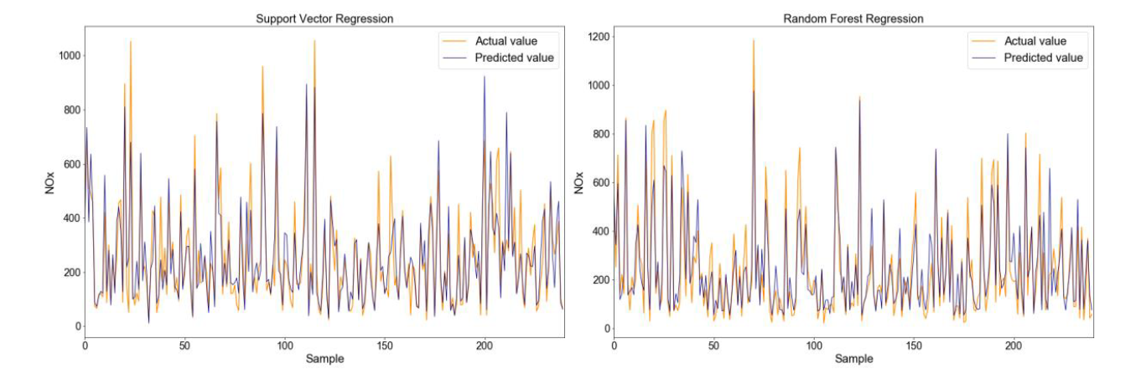

Figure 2.3: Sample testing line chart of ${NO}_{x }$

In figure 7, x-axis represent the sequence number of the testing samples and y-axis denoting the ${NO}_{x }$ of an Italian city and based on the results of experiments they found RFR is better predictor than SVR to predict the ${NO}_{x }$ concentration.

### Air quality forecasting based on cloud model granulation

In air quality forecasting Machine Learning [ML] and Soft Computing [SC] approaches can give optimized results. Because forecasting air quality is complex which data sets are nonlinear, heterogeneous and uncertain [19, 20, and 22]. There are three categorical ways on air quality forecasting. They are follows: (1) Simple empirical methods, (2) physically based methods and (3) Parametric or non-parametric statistical methods.

**Simple Empirical Methods**

There are 2 ways to predict future values in simple empirical methods. The first ways is Use present day’s value and second ways is dependencies between meteorological variables and predicated air pollutants but both way are low accuracy.

**Physically based methods**

It is the temporal and spatial patterns of air pollution and weather variables [1] and this method is better than simple empirical methods.

**Parametric or non-parametric statistical method**

This method is better than physically based method in accuracy [2]. For an example neural network

Even though there are many advantages there are some disadvantages in artificial intelligent. At very first, these models cannot be used in other places because it is developed under certain chemical and meteorological condition of one place. Second one; always simplify the process of meteorological. Third, the relationships between different pollutants are not modeled. Neural network can build the non-linear relationships between objective function and independent variables because of that it has more accuracy than non-linear regression.

The aim of this study is to develop a means of forecasting the quality of the air, which can compensate for the uncertainties in the data at low computational cost and good generalization performance. Not just this mechanism considers ambiguity and inconsistency, but also through three different modification state spaces to reduce data. For that first they granulate and mapped the original data in the time series into new time series into the feature space. After that extracted the granule of each cloud model feature and performed the deductive reasoning. At last, the proposed algorithm resolved the actual problem based on the task to be solved and related knowledge, from feature of data space to the concept space. In this research they used the grid search to optimize the parameters and they make sure proposed algorithm capable to (1) Modeling uncertainties between data sample point of time series; (2) Maximizing the generalization performance; (3) and costing low computational cost.

Here for this experiment they got datasheet from Wuhan Municipal Environmental protection Bureau and it included information of maximum daily emission of NO2, SO2, CO, O3, PM10, PM25 and other details such as AQI and AQI class. This data was collected from three location [Ganghua of Qingshan District (GH), south area of Jianghan District (JHS), and new area of Zhuankou] locality (ZKX) from 2016 to 2017. There are three approaches to deal with data which missed before modeling: (1) deleted the data record which has missing data, (2) Replaced the missing value and (3) used multiple imputations but in this experiment they used average values for numeric attribute instead of missing value. Here Individual Air Quality Index [IAQI] means air quality index calculated to each and every pollutant individually. IAQI is calculated based on following formula.

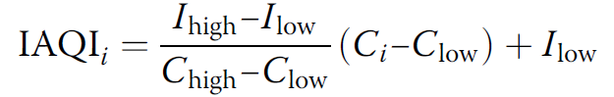

- Input concentration for a given pollutant

- Nearest concentration breakpoint that is ≤ C

- Nearest concentration breakpoint that i ≥ C

$I_{low}$– Index breakpoint corresponding to

- Index breakpoint corresponding to $C_{high}$

IAQI is linear function according to pollutants concentration breakpoint. Like that the total health impact would be combination of each pollutant [15]. Ministry of Environment protection [MEP] in china released formula for AQI as follows:

AQI = max ( ${IAQI}_{1}$, ${IAQI}_{2}$, ……., ${IAQI}_{n}$)

It says to select maximum IAQI as AQI without considering the interaction between pollutants.

In this research they proposed Regression predication algorithm based on cloud model granulation and support vector machines.

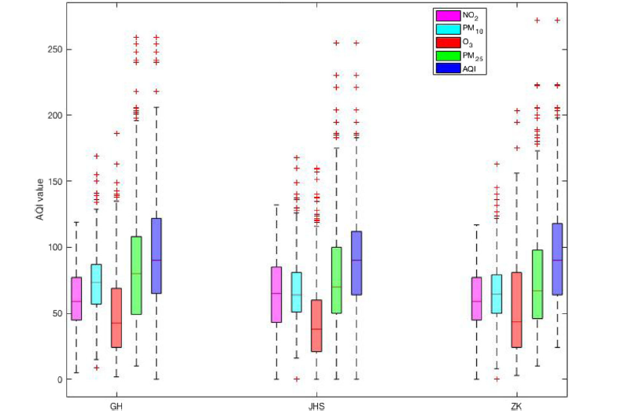

Figure 2.4: Boxplots of IAQI and AQI in three locations

**Algorithm based on cloud model granulation**

In this paper suggest an method based on concept of cloud model and the conversion of state space on time series prediction of Aps and AQI. This is efficiency and generalized performance. This is model of mutual conversation between quantitative description and qualitative description. It is an integrated model of fuzzy set theory and probability theory. This model does not need any prior knowledge and it can analyze the statistical rules from large data set and realize the transformation from quantitative value to qualitative concept [16].

This model has three digital features: exception Ex, entropy En and super entropy He.

Exception Ex, representative qualitative value in the domain space. Entropy En, range of number domain that accepted by the concept. Hyper entropy, measure of uncertainty of entropy. The suggested algorithm translates the distribution characteristics of data samples in each granule into qualitative concept present by above three digital feature [16].

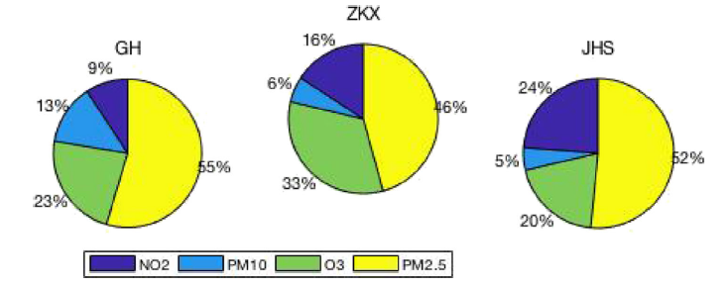

Figure 2.5: Percentage of impact on AQIs in selected three locations

## Summary

This chapter, we have critically reviewed the literatures that are closely related to our project or independent modules of our project. The next chapter will be describe the technologies that we are going to use in this project and how we are looking forward to using the technologies in the project.

# 

**Technology Adapted**

## Introduction

This chapter going to discuss about the technologies that used to resolve the addressed problem in introduction section. It also discusses the requirement of these technologies and the importance of the technologies in the project to achieve our proposed solution.

## Required Technologies

### Python

It is the one of the Object Oriented Programming language which supports more than 300 standard libraries. It is used to develop web application, data science and so on[28].

### ANN

Neural networks are computational model which are basically an attempt to make a computer model of the brain[29]. The term “Artificial Neural Network” is derived from Biological neural network that develop the structure of a human brain. Similar to the human brain neural network have neurons that are interconnected to one another in various layers of the networks. These are known as nodes.

It has more advantages. Follows,

* Parallel processing capability.
* Storing data on the entire network.
* Capability to work with incomplete knowledge.
* Having a memory distribution.
* Having fault tolerance

### Arc Map

Arc Map is a main component for geological processing programs and it mainly used to create, manage, share and analyze spatial data[30]. It consists of sever components, mobile and desktop applications and developer tools. The ArcGIS platform consists of many components that communicate with each other via ArcGIS REST API and common file formats. In our project we mainly use this tool to create customized map.

### PostgreSQL

* It is open source object-relational database system and it is uses extend the SQL language.
* Free and open source.
* Support different programming languages.
* It has many features aimed to build applications, administrators to protect data integrity and build fault-tolerant environments and help you manage your data.

### Tensor Flow

It is a framework for creating ensemble algorithms for today’s most challenging problems. Also, it is used backend purpose for our project.

Tensor Flow is a free and open-source software library for dataflow and differentiable programming across a range of tasks. It is a symbolic math library, and is also used for machine learning applications such as neural networks. Also it has better computational graph visualizations, which are indigenous when compared to other libraries like Torch and Theano. Tensor flow lets us to execute subparts of a graph which gives it an upper- hand as you can introduce and retrieve discrete data onto an edge and therefore offers great debugging method.

### SKLearn

For classification algorithm Scikit-learn (SKLearn) is also an open source machine learning library which is based on Python language. SKLearn highly support for regression, classification and clustering algorithms. In character recognition module classification algorithms have to be used for train data. Since SKLearn library highly support for classification SKLearn library is intended to be used for the developments.

### PostGIS

PostGIS is spatial database extention for the PostgreSQL database management system. It is designed for processing and manipulating data which has spatial characteristics[31]

### GeoDjango

It is a geographical web framework and it helps developers to make easy to build GIS web applications.

## Summary

In this chapter we discussed about required technologies which are used to implement the project and also mentioned the purpose of those technologies in the project. The next chapter will describe our approach which tells you how we used above technology to implement our project.

# 

**Our Approach**

## Introduction

In this section we are going to discuss about our approach in resolving the problem which we identified during the introduction section using the necessary technologies. It further describes users of the proposed application, types of input data, process that take place within the system and expected outputs of the system.

## Project Approach

### System

The system analyzes the Air Quality Health Level [AQHL] based on the different features and generating the optimized path for the commuters in the urban road. The flow of activities that will be taking place in the major modules of the system are explained as follows

#### AQHI (Air Quality Health Index) and AQI Health level Prediction

**AQHI prediction**

AQHI was developed by Environmental Protection Agency [EPA][32] and it is use to convey to us how clean or polluted your air is and what associated effects might be concern for you. AQHI focuses on health impact you may experience within few hours or few days after inhaling polluted air. In our project we are going to calculate standard AQHI values of O3, PM25, NO2 gases. Using the concentration of above gases (O3 and NO2) and PM2. 5 ( atmospheric particulate matter) we calculate the AQHI of air in the particular place. The higher AQHI value is the greater level of air pollution and lower AQHI is the lower level of air pollution. For a examples,

An AQHI value of 20 indicate that good air quality with little potential to affect public health, while AQHI value over 50 indicate that hazardous air quality.

Following table shows the AQHI level for varies gases.

Table 4.1:Guidance for air quality Index

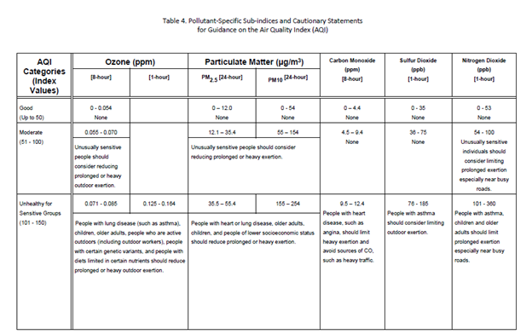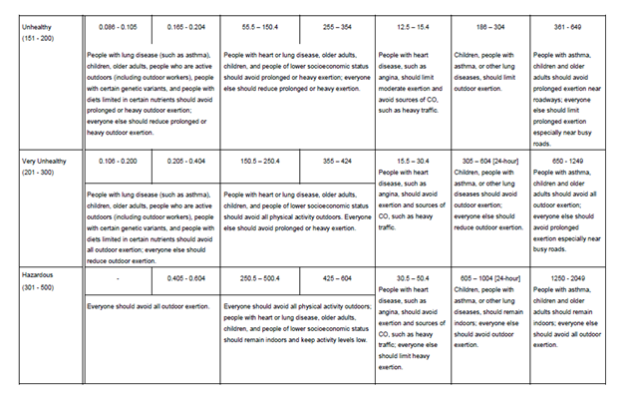

We used following equation to calculate the AQHI [6].

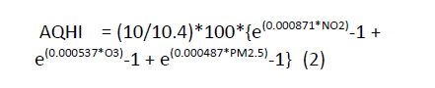

Then using the ANN and Random forest Regression model we predict the AQHI for particular place. In here we mainly considered the Time, Region of the place, Day (weekend or week days), and Concentration of the O3, NO2 and Value of PM2.5 as an input and predict the AQHI for particular place.

#### Identifying AQHI Health Level

There are 6 separate AQI levels as following, Good, Moderate, Unhealthy for Sensitive Groups [USG], Unhealthy, Very Unhealthy and Hazardous. The breakpoint for each category were developed based on established national air quality standards[33]. In this module we identify the health level of air based on the day, time, the region of the place and AQI. The higher AQI is fall into dangerous zone and the lower AQI fall into good category. Good air quality is indicated by low number and worse air indicated by higher number [18].

The image below shows standard level for AQI.

Table 4.2: Standard level for AQI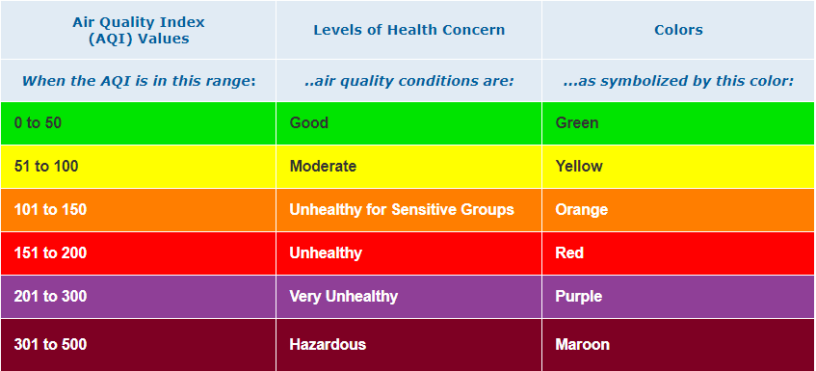

Table 4.3:AQI health level Vs. Consequence

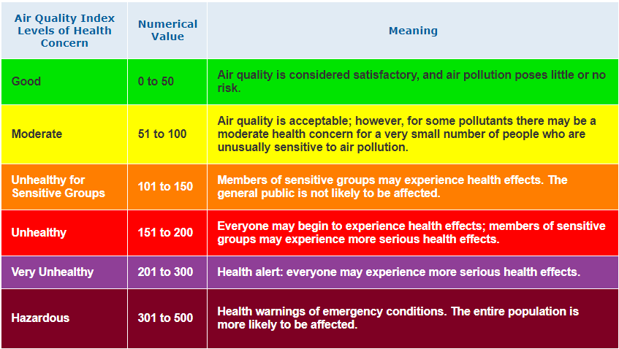

According to our objective we give the different threshold value for Good, Moderate, Unhealthy level. Therefore according to the region of the place (school, hospital, and normal) we give the different threshold value. Because, if the place is ‘Hospital’ we have to give the very less threshold value for the ‘Good’ level due to the reason of it is very high sensitive place. If the AQHI increased very slightly it will affect the health of patients very drastically. And also if the place in within the school region then then we mainly considered the weekdays and weekend days separately. Because the traffic jam will be increased in the weekdays. So we have to give less threshold value for the ‘Good’ level in the weekdays and little more threshold value for the ‘Good’ level in weekend days.

According to the threshold value we calculate the AQHI level for particular place.

#### Finding optimize route

This module was implemented to give the suggestion to the transportation commuters who use the system. According to the predicted AQI level of every route we suggesting to continue or to navigate to different route using by showing traffic in every route. The higher AQI HL [Air Quality Index of Health level] indicates that the air is polluted. So that route has higher vehicle traffic. Through showing the traffic we navigate user to another route. We prevent that particular area from further contamination through navigating the vehicles to another route. In here we get the assumption as there is no pollution emitted by the user.

We use two different modules to predict the AQI such as Artificial Neural Network and Random forest Model and here we mainly took three regions as hospitals, schools and normal places.

### Users

Our system provides automatic optimized route for transportation users. We identified general public group who use the system and who are in need of automatically finding traffic information are the users of our system. The main beneficiaries are school students and hospitalized patients. Because in our project we mainly focused on reducing the environment pollution based on the AQI by reduce the traffic on the particular route and we consider the region such as school, hospitals in the particular route.

From literature we have analyzed it is clear that our project is a novel one consisting of a combination of research areas that should be addressed in order to provide solution to identified problem. As of research value, this system can be used by the researchers to identify and further study about Air pollution and health risks due to vehicle traffic based on the concentration of the different air pollutant and other features.

### Inputs

The initial inputs for the system are,

* Starting place and Destination place
* Time and Date

Table 4.4:Input table

|  |  |
| --- | --- |
| **Module** | **Input** |
| AQI prediction and  Identifying level of health concern | Concentration of the gases for predicting AQI |
| AQI  Time and Date  Region of the place |
| Finding the optimize route | Longitude, latitude of Starting and Destination place |
| Future simulation | Current AQHI for particular place, last week AQHI for all hours |

### Process

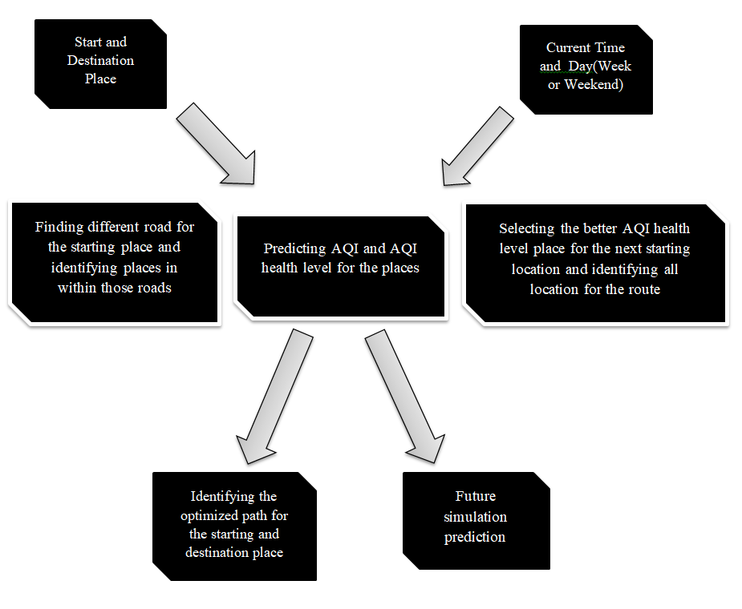

Figure 4.1: Overall process

### Outputs

Table 4.5:Views of Output table

|  |  |
| --- | --- |
| **Modules** | **Output** |
| Predicting AQHI and  Identifying level of health concern | AQHI for a particular place |
| Level of Heath concern in a particular place(school, hospital, normal region places) |
| Identification of optimized route | Optimized path |
| Future simulation prediction | AQHI Health level for next hour in a particular place |

## Summary

In this chapter we discussed briefly on the proposed solution, modules wise inputs, flow of implementation and module wise outputs. Next chapter we are going to illustrates the design of entire system along with the comprehensive explanation of the individual module implementation.

# 

**Analysis and Design**

## Introduction

In this Analysis and design chapter discusses the design of the system that is proposed for the problem addressed in the introduction section. It consists of the top-level architecture of the proposed system and conceptual designs of each module in the system. It provides a description about what is done in each module and relationship among modules.

## Architecture of System

### High level architecture of overall system

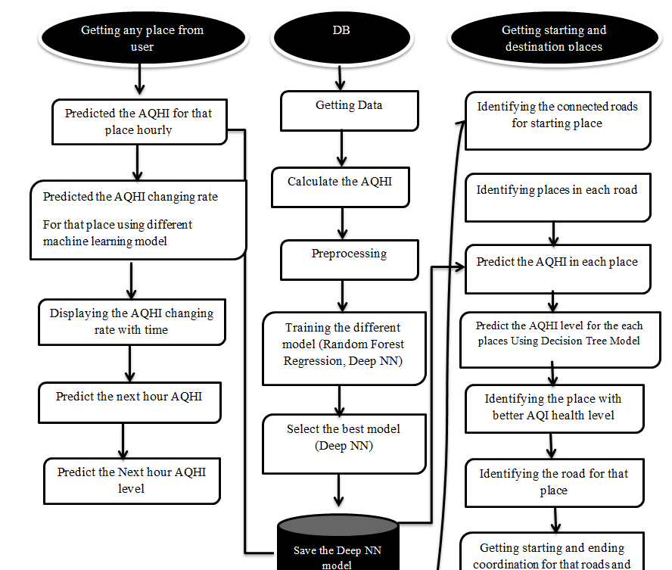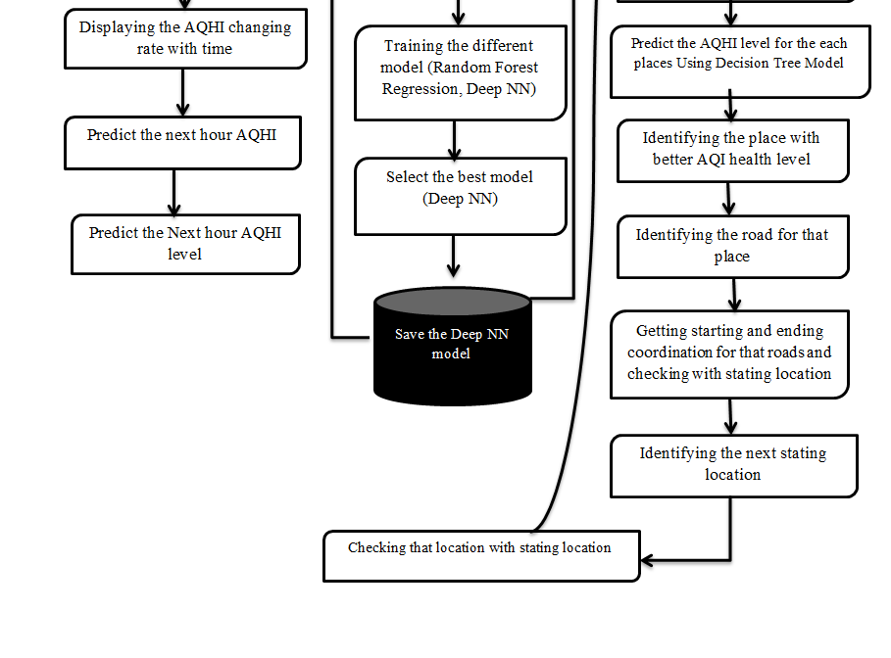

Figure 5.1: High Level Architecture of the System

### High level architecture of individual module

#### Predicting the AQHI

The objective of this module is to predicting the AQHI of the NO2, O3, PM25, SO2 concentrations based on the breakpoint for the NO2, SO2, O3, PM25 concentrations. The AQHI was developed by the EPA and is used to express that how clean or polluted the air around you[33].

Here we mainly focused on O3, NO2, and PM25. However, there are also standards for other gases too. Information on all pollutants and a detailed guide by the EPA is also available. And also the EPA has developed a quick and easy AQI to Concentration and Concentration to AQI calculator[18].

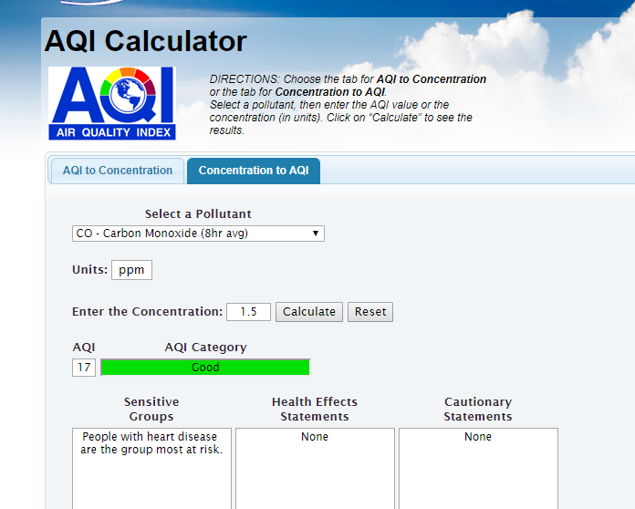

Figure 5.2 : View of AQI calculator on EPA website

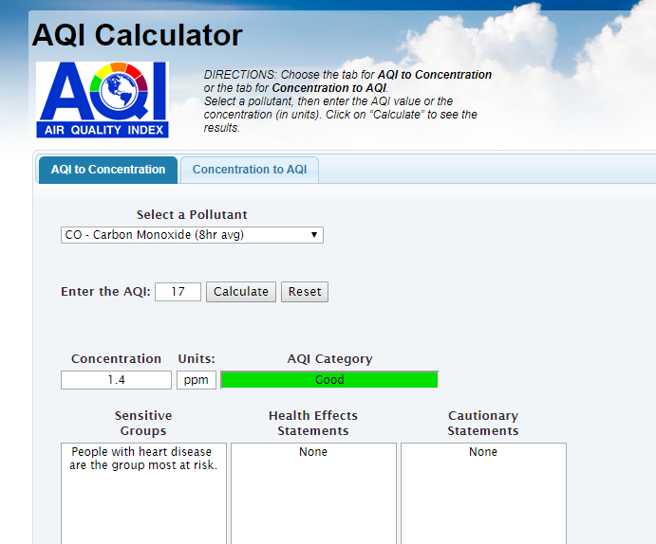

Figure 5.3: View of AQI calculator on EPA website

Then using below equation and truncating points for NO2, O3 concentration and PM25 we calculate the AQHI.



Then using the time, region, concentration of the O3 , NO2, and PM25 value we predicted the AQHI for particular place.

**Data Collection**

Here we found the research problem as generating the suggestion to the commuters to navigate the different route or to continue the same route based on the different features of the environment. Initially we used the data set from the online as <https://aqs.epa.gov/aqsweb/airdata/download_files.html#Raw [11]. 34>

But these data set not enough for us according to the objective. For our project we need the data about region wise such as the particular place is located near the school or hospital or normal place. Also we need the concentration data in every route. From above data we couldn’t find the solution for our problem. Because of that we used dummy data for our model and we created proto type system.



Figure 5.4 : View of Dataset

**Preprocessing Data**

It is a data mining technique that transforms raw data into an understandable format. Raw data (real world data) is always incomplete and that data cannot be sent through a model. That would create certain errors. That is why we need to preprocess data before sending through a model.

Here we have done preprocessing using these steps.

**1. Import libraries**

We were used Pandas, Numpy as main libraries and for the visualization we were used Matplotlib and Seaborn.

For the data preprocessing techniques and algorithms, we used **Scikit learn** libraries.

**2. Read data**

Read the data set from particular directory using pd.read_csv() method.

**3. Checking for missing values**

Check missing value. There was some missed value in that sheet. Then we removed those missing value rows because those were not importance for our problem.

**4. Checking for categorical data**

Here we checked that categorical data. Date is a categorical data. Then we changed to the date as 0 or 1 based on that week day or weekend day.

**5. Standardize the data**

We found that there was the scaling problem in our data set. It will affect to the accuracy. So we used the min max Scalar to standardize the data set.

**6. Data splitting**

Finally split the data set as train and test data and validation data.

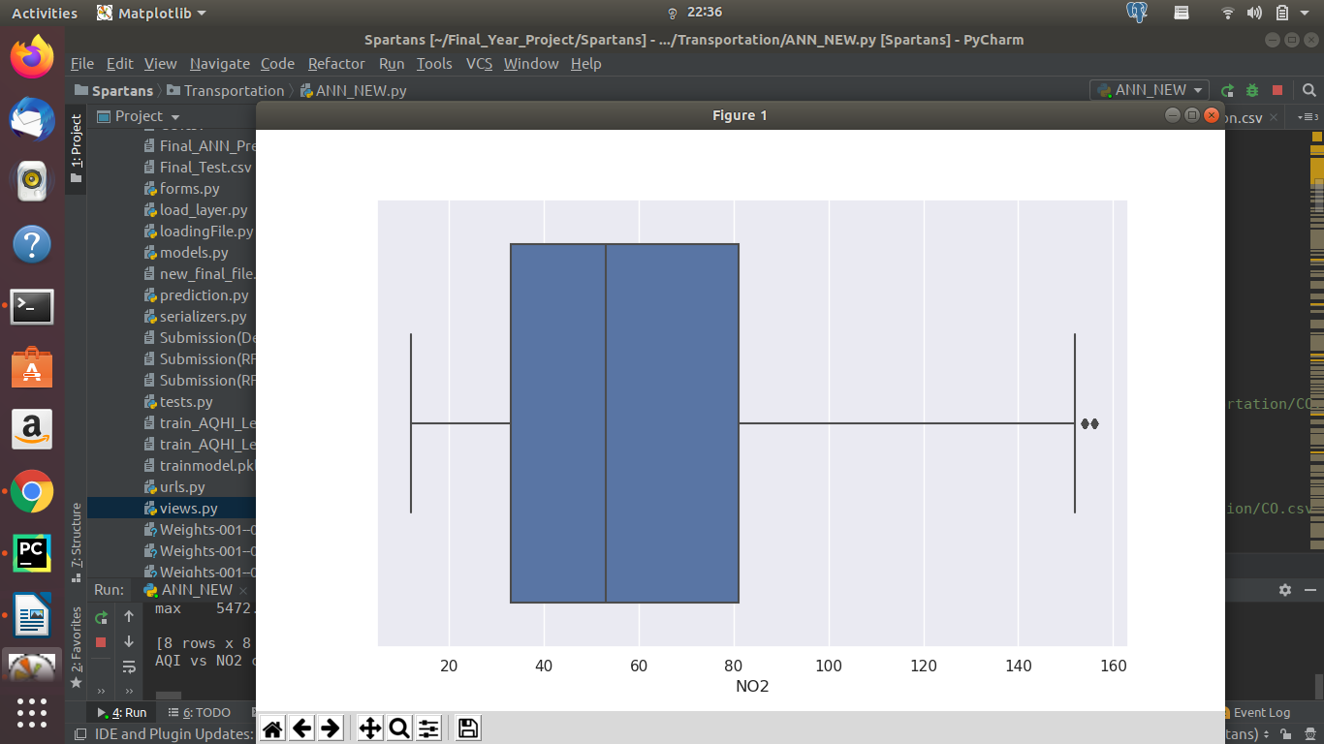

Figure 5.5: Confusion matrix

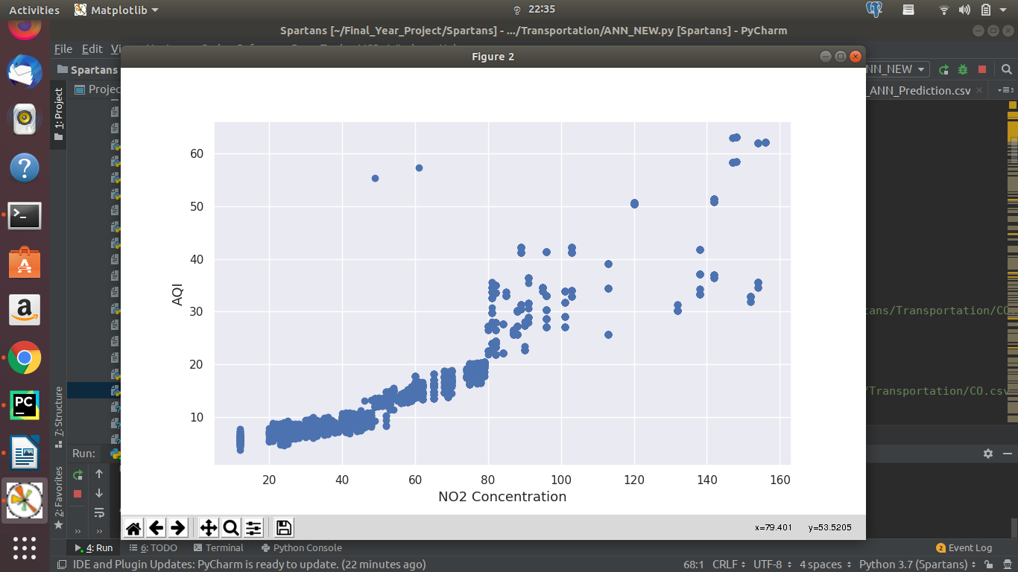

Figure 5.6 :Confusion matrix

**AQHI prediction using machine learning approach**

According to the problem the machine learning model will be classifier or regression. If the target value is categorical then machine learning will act as a classifier. If the target value is numerical then the model will act regression. The initial step when training a machine learning classifier or regression problem is feature extraction. Then, the training data is fed to the machine learning algorithm that contains of pairs of feature sets and tags to produce a classification model or regression model. After the classifier is trained with training data, the machine learning model can be used to make accurate predictions of previously unseen records, without human intervention. The same feature sets which can be fed into the classification model or regression model to get predictions on tags. If the model is classification model then based on the prediction accuracy will be calculate. Model with high accuracy considered as a best model for the particular problem. Otherwise mean absolute error or mean square root error will be calculated. Then model with less accuracy will be consider as a best model

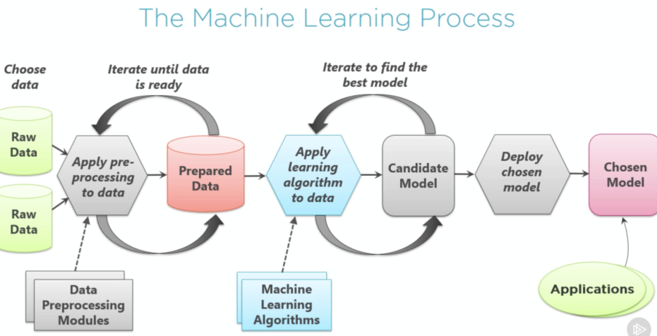

Figure 5.7 : Machine Learning Process

According to our problem it was a regression problem. For the model we used the training, testing data files. Both are included Id, region, place id, Time_GMT, Wday, O3, NO2, and PM25 as an input. Initially we calculated the AQHI only for the training dataset using the standard equation and added into the training dataset. Then the dataset was go through the preprocessing steps such as removing the null value, removing the duplicate value, and normalizing the data using the Min max scalar. Then we drop the AQHI value from the training dataset and considered as a target value. Then training and testing dataset was combined and checked the categorical and numerical features. Then split the data set as training and testing. After that using the ANN model the dataset was trained and validated. Using the testing data set the model was tested and finally means squared error was calculated.

And also the training data set was trained using the Random Forest regression model. And mean squared error was calculated. Then the best model was selected by considering the less means squared error. So the ANN model was selected as a best model for the AQHI prediction.

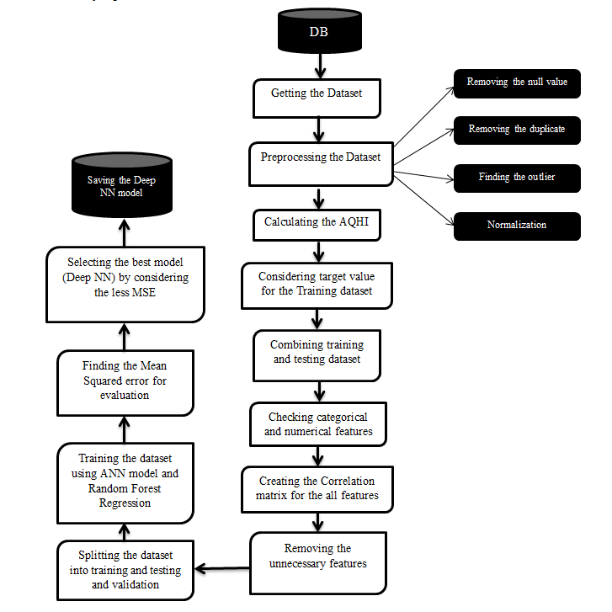

Figure 5.8: Over all process of predicting AQHI

#### *Predicting the level of the Health Concern Module*

Table 6:Break point for AQI

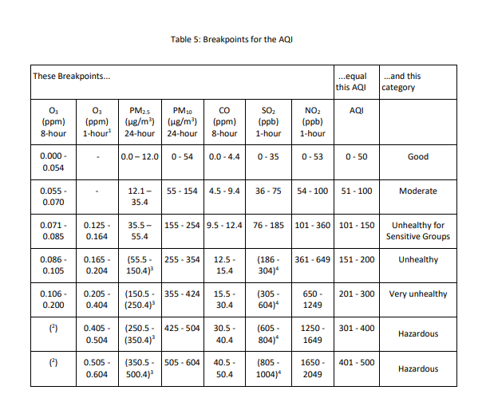

The objective of this module is to identify the level of the Health Concern for the AQI. There is a standard category for the AQI such as good, moderate, unhealthy, very unhealthy, etc. But here we assumed that this AQI values for the categories are different to region to region. Based on the region and date and time we divided the categories differently. For example the hospital region is considered as a very high sensitive place and it was given very less truncate value for the ‘Good’ Health level of AQI. Likewise within the school region also based on the weekdays and weekend days the different threshold value was given.

According to the thresh hold value the health concern of the particular place was calculated for the training dataset and considered as a target value for the training dataset. The AQHI for the testing dataset was predicted using above model and added to the testing dataset. Using random Forest regression and Decision tree Regression model ‘Health concern level’ was predicted for the testing dataset and using training and validation dataset Mean absolute Error for the models are calculated and using MAE the model was evaluated. Finally the decision tree selected as a best model for the prediction of the Health concern level. Then using model we predict the level of health concern in particular place.

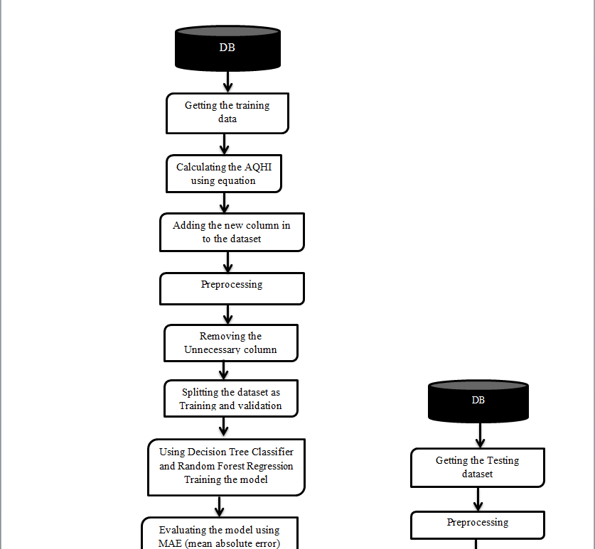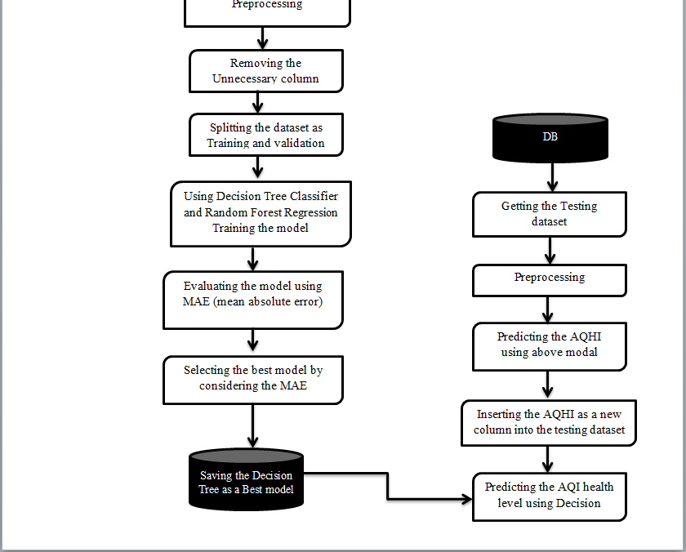

Figure 5.9 : Process of forecasting AQHI Level

#### *Optimal Route service*

The main objective of this module is generating the Optimized path for the commuters to navigate the different route or to flow the same route based on the different health concern of the places. Initially we have to connect the backend to ArgGIS in order to use the map to display the paths to the users. To accomplish the module initially we created our own customized map using Arc Map. Here we marked all places that are used in our dataset.

This map has three region of the place as schools, hospitals, normal place and junctions. Here we used postgreSQL database to store those data in each separate tables and there is a separate table to with the details of Junction Vs. connected roads. We store relevant details manually.

When the user uses system to get the optimized path, initially we are getting the starting and destination places from the users. Then based on the starting and destination places we are finding the all connected rode for the particular staring place. Then available places in every route were identified.

Then using above model the AQHI and AQI health level for the places was predicted. After that according to the health concern of the places the better route was identified. In that time initially checked that the places include the ‘Good’ health concern level or not. If the places include the ‘Good’ health concern level then those places are selected.

According to the AQHI level, if there are many ‘Good’ AQI of Health level available, select the all ‘Good’ level places separately and find the distance between starting point and destination to select the shortest path among them by using the Dijkstra’s shortest path algorithm and short those paths.

Then less distance place was selected as a next starting location. If that places does not include the ‘Good’ Health concern level then the moderate place was selected as a next stating location. Then that starting location was tested with the destination. If the staring location does not equal to the destination the above process was continued until the stating location is equal to the destination. Finally latitude and longitude for the all starting and destination places was finding and optimized path was suggested.

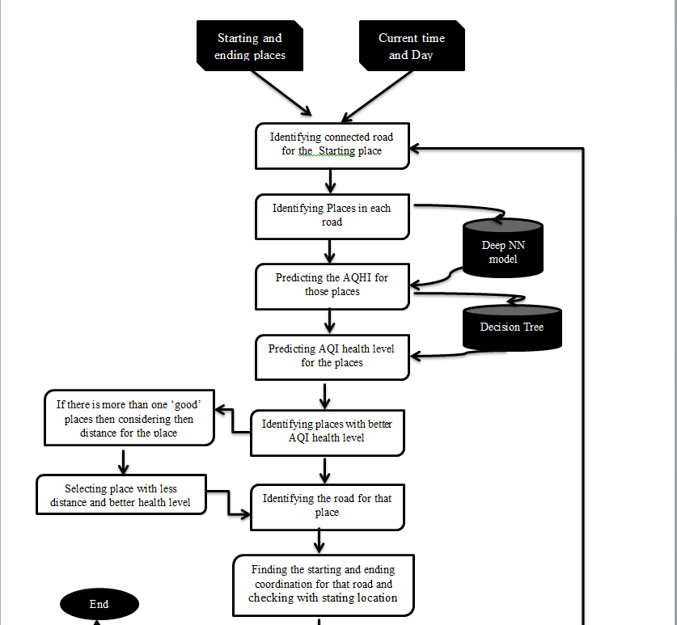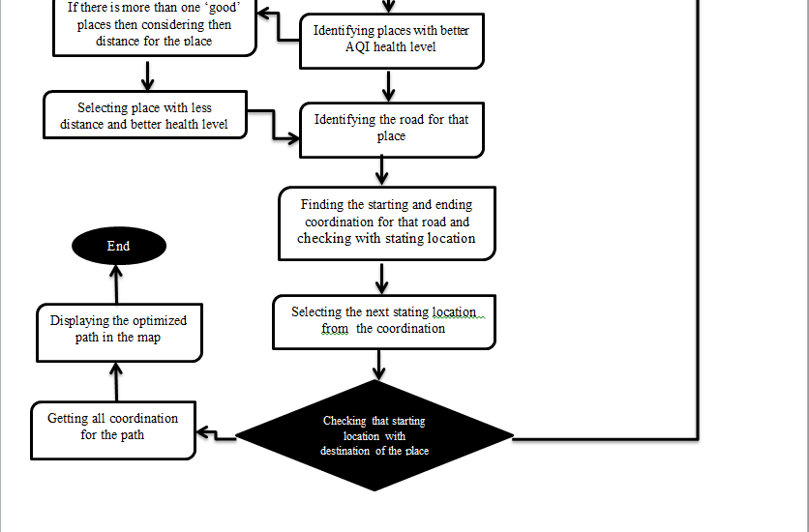

Figure 5.10 : Overall process for Optimizes route

#### *Future simulation prediction*

This module helps to user to know about coming hour AQI health level of the place. If any user wants to know about the coming hour traffic jam in a particular place they can identify through this module. Initially for the particular place (Hospital place was selected) for all 24hours AQHI was predicted using above models (Deep NN). Then using that AQHI and time the AQHI changing rate was calculated using this equation.

Rate of Change of AQHI = (next hour AQHI – present AQHI)

Then Rate of change of AQHI was considered as a target value for the training model. Then Rate of change of AQHI was predicted using ANN, Random Forest and Decision Tree models. Then those models were evaluated by considering the MAE. The model with least mean absolute error was selected as a best model for predicting Rate of Change of the AQHI. Finally the decision tree regression model was selected then rate of change of AQHI with time was displayed.

Then for a given particular hour AQHI with next hour AQHI level was predicted. For that Current time AQHI, time, Rate of change of AQHI was considered as an input. AQI health level for next hours was considered as a target value. Then using different model the AQI health level for coming hour was predicted. After that MAE (Mean absolute error) was calculated for to evaluate those models. The model with less Mean absolute error was considered as a best model. Finally the decision tree model was selected the best model for the AQI health level for future hour prediction.

For example if anyone wants to predict the coming hour AQI health level for the particular place with current AQHI 20 with current time 2.00pm. Then initially for that place for the particular day last week data will be get and AQHI for that day (all 24 hours) will be predicted using the ANN model. Then rate of change of AQHI was predicted. If the rate of change of AQHI is positive value then the coming hour AQHI will be increased. Then the coming hour AQHI was calculated. After that the current time, current AQHI, Rate of change of AQHI, coming hour AQHI will be considered as a input for the decision tree model and coming hour AQI health level was predicted.

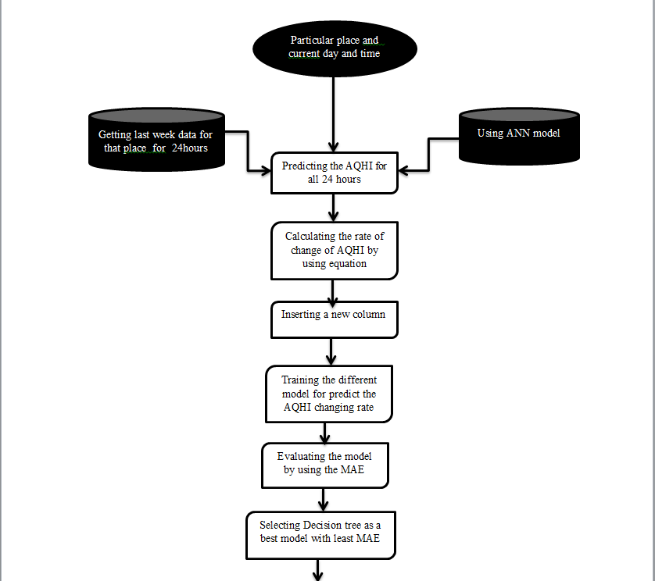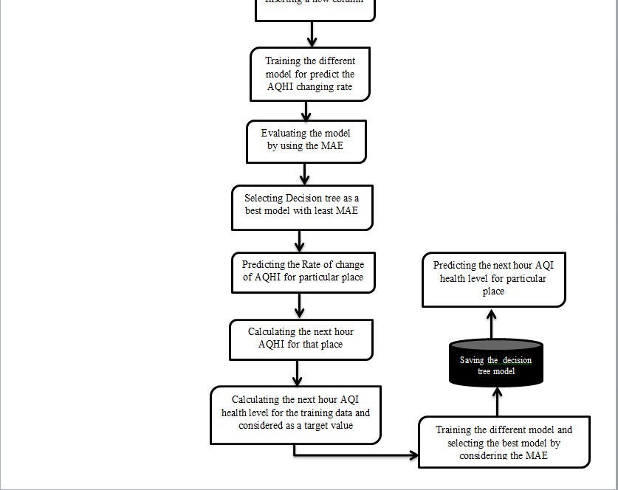

Figure 5.11 : diagram for Forecasting module

## Summary

This chapter discussed about the design of the solution that is proposed for the problem addressed in the research. It included the top-level architecture of the proposed system and the designs of each module in the system. It gave a description about what is done in each module and relationship among those modules.

# 

##### Implementation

## Introduction

The previous chapter on Analysis and design gave details on the top level architecture of the system that is to be developed. It also pointed out the individual modules in the system, who the users and what sort of an input is to be fed into each modules. This chapter provides a descriptive implementation detail of each module mentioned in the previous chapter.

## Predicting the AQHI and AQHI level

### Preprocessing Module

The initial process of any machine learning task includes the Preprocessing. In here initially we removed the null value, duplicate value and outlier. Then we got the description about every feature in the dataset and understood about min, max, mean, etc. for every feature. Then we checked the date is that week day or weekend day. We created new feature “Day” by assigning day=1 if it is week day and day=0 if it is weekend day. Then we removed the date feature and we created the “Day” as new features. Visualize the correlation matrix heat maps. It shows correlation coefficient between variables.[34] It is extremely powerful way to visualize relationships between variables in high dimensional space. Then, by visualizing heat map we removed the less unnecessary columns.

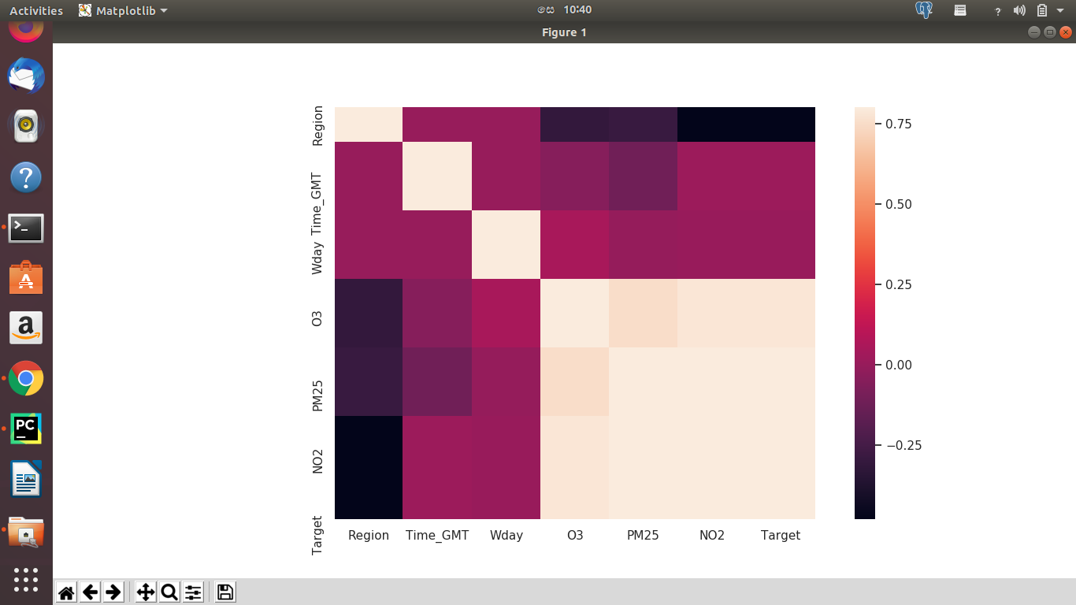

Figure 6.1 : Correlation Matrix

### Predicting the AQHI

To predict the AQHI we get the ‘Region’, Time’, ‘Wday’ , ‘O3’, ‘PM2.5’, ‘NO2’ as a input for the training model. Then we have found the Air Quality Health Index for concentration of the NO, O3 and PM2.5 by using the standard equation. Then we added AQHI as a new column. And removed that column from the training data and assigned that column as a target column. Then we combine the training data set with testing data and we removed the id column. Then we identified Categorized and numerical columns. In our dataset there is no categorical value. All are numerical values. Then, the data set was normalized using the MinMax scalar. Because scaling the dataset is very important in the training dataset. Because of that the input features have similar orders and magnitude. Then we split the data set as training and testing. After that we used the Deep Neural Network model for training the data. In here we set up the architecture with six hidden layers and input and output layer.

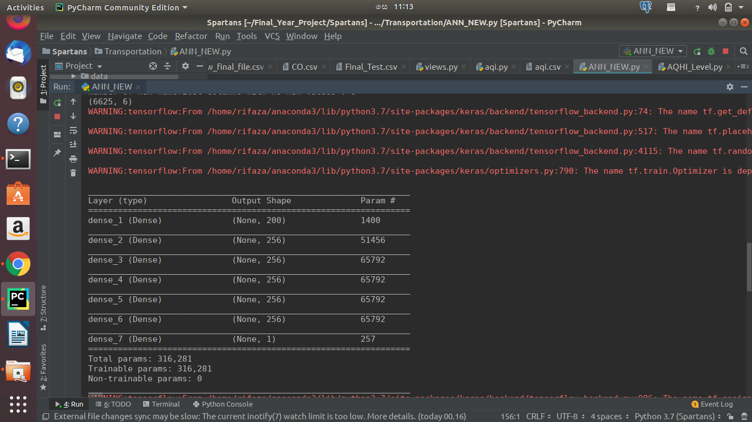

Figure 6.2 : The layer of the system

We used ‘relu’ activation function for the input and hidden activation function. ‘Linear’ as an output activation function because the output is a numeric value. It is a regression problem. Because of that we can’t use the ‘relu’ activation function for the output layer. And we used the 400 epoch and best checkpoint was saved for testing the model. And also we used the ‘absolute error’ and ‘adam’ optimizer. In that time the loss value is high. Validation loss 0.00263 is got for the best checkpoint.

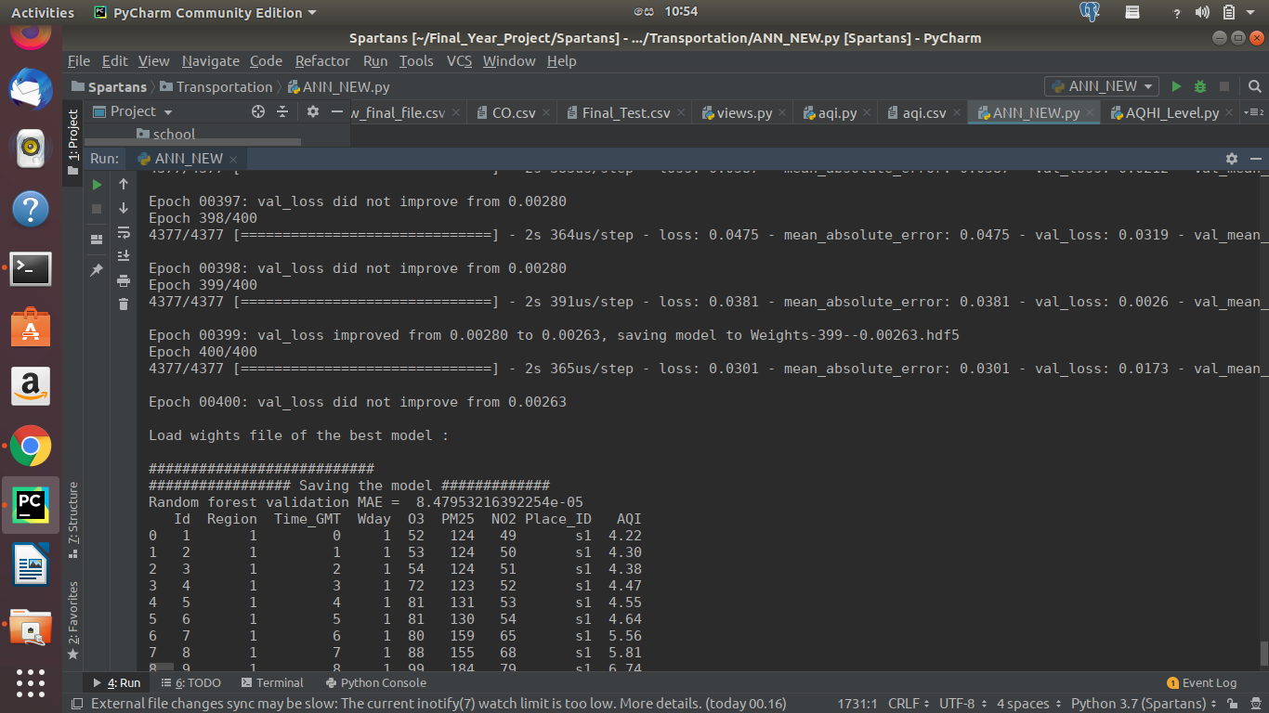

Figure 6.3: View of loss value for checkpoint

Then we test with the ‘mean squared error ‘and ‘adam’ optimizer for the accuracy. And get the less loss value when using the ‘mean squared error’. Validation loss 0.00001 is got for the best checkpoint .Finally we saved the trained model.

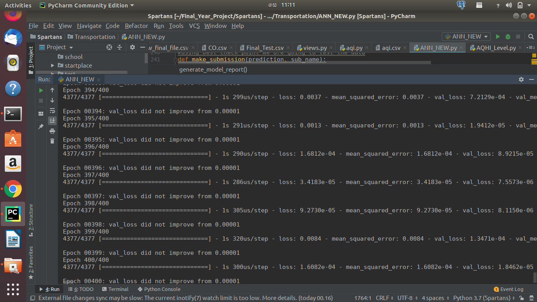

Figure 6.4: The best loss value for checkpoint

And also we trained the model using Random Forest regression. And get the mean absolute error as 0.000075. So finally selected the ANN as a best model for the problem

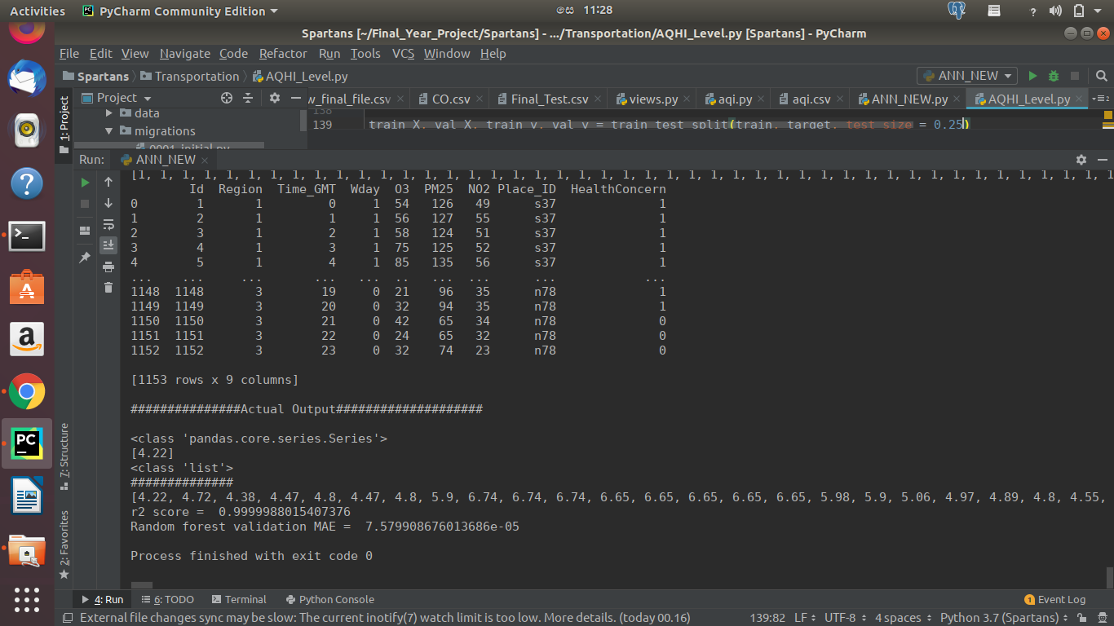

Figure 6.5 the absolute error of the random forest

### Predicting the AQI Health level

We got the starting and destination from the user and get the current time and current date .If the day is weekday it will considered current day as a ‘1’ and if it weekend it will considered current day as a ‘0’. According to starting location we identified the connected road for the starting location and then we identified the available places (Hospital, School, and Normal) in each road.

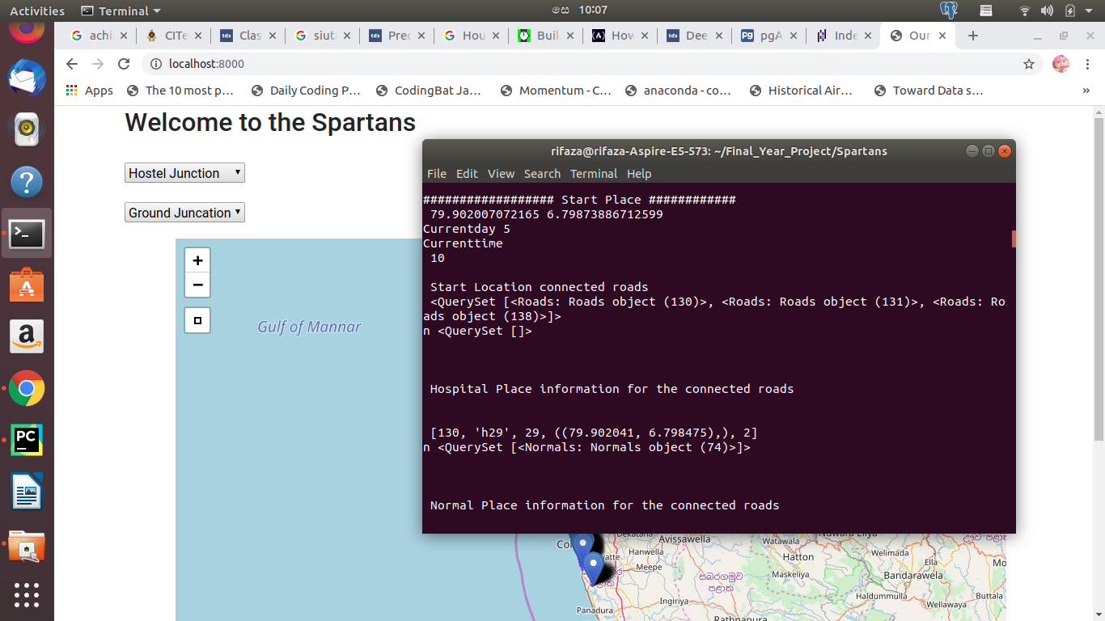

Figure 6.6 Shows the details of connected road

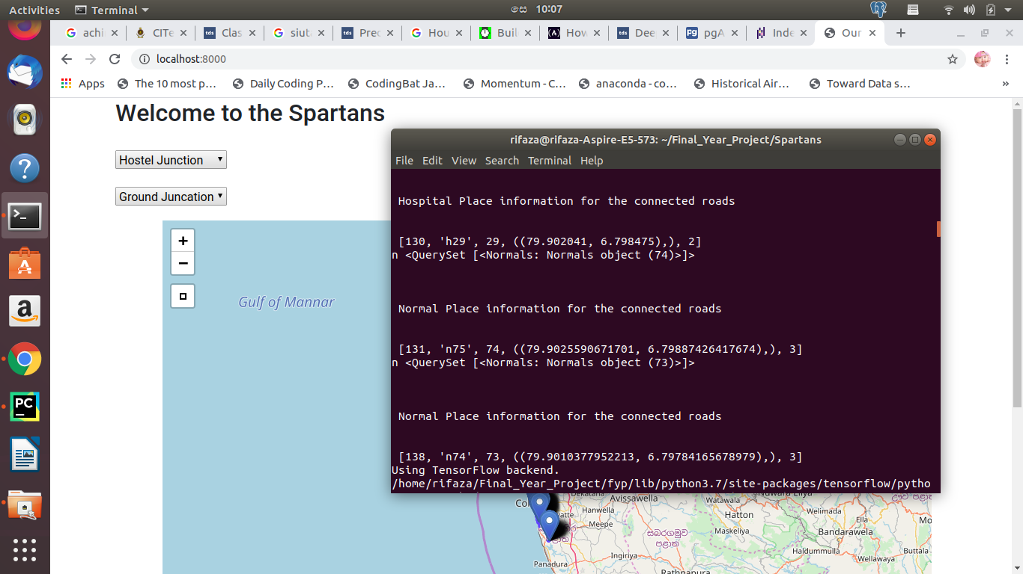

Figure 6.7 : The details of places in the connected road

Then we got the concentration of the each location using the road id, region id, coordination of the location. Then we predict the AQHI for those places using the trained model.

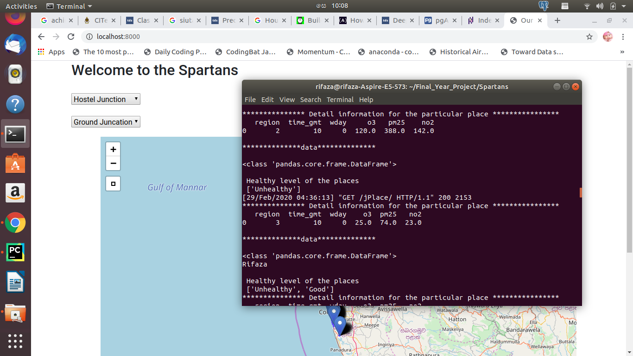

Figure 6.8 : The details of the places

Then using the Region id, and AQHI, time and region we predict the AQHI level. There are 6 separate AQHI levels as following, Good, Moderate, Unhealthy for Sensitive Groups [USG], Unhealthy, Very Unhealthy and Hazardous. The thresholds for each category were developed based on established national air quality standards, region of the place and weekdays and weekend days. In this module we identify the health level of air based on the day, time, the region of the place and AQI. The higher AQI is fall into dangerous zone and the lower AQI fall into good category. Good air quality is indicated by low number and worse air indicated by higher number [8].

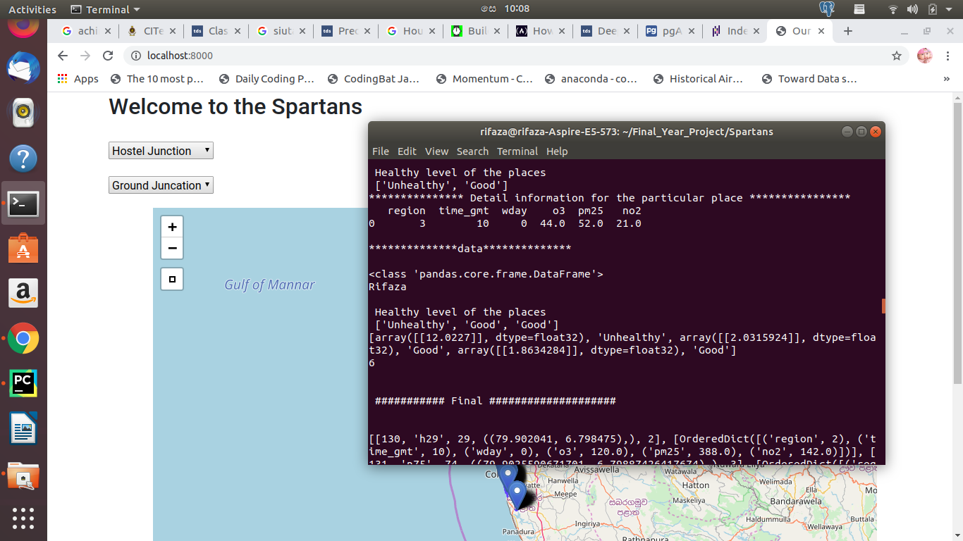

Figure 6.9 : The predicted AQHI health level of the places

## Finding the optimal direction

In this module helps users to find the optimal path to travel. Here we mainly considered two factors to find the optimized route as follows: one is AQHI level as a main factors and second distance between starting and destination. According to our project aim we have to reduce the environment pollution near the hospital and school regions because of that we give the first priority to the AQHI level and as second option to the short distance.

First of all select the starting point and destination point. Here we choose starting points as some junction for reduce the complexity and find the connected road using “Junction with connected road” table in postgreSQL database by querying the database. After that, find the places situated in the each road using the road id and get the all other information related to the each places such as (latitude, longitude, concentration of the gases and other information).

Using the AQHI predicting module predict the AQHI health level of each places in the roads from using the concentration which retrieve by query.

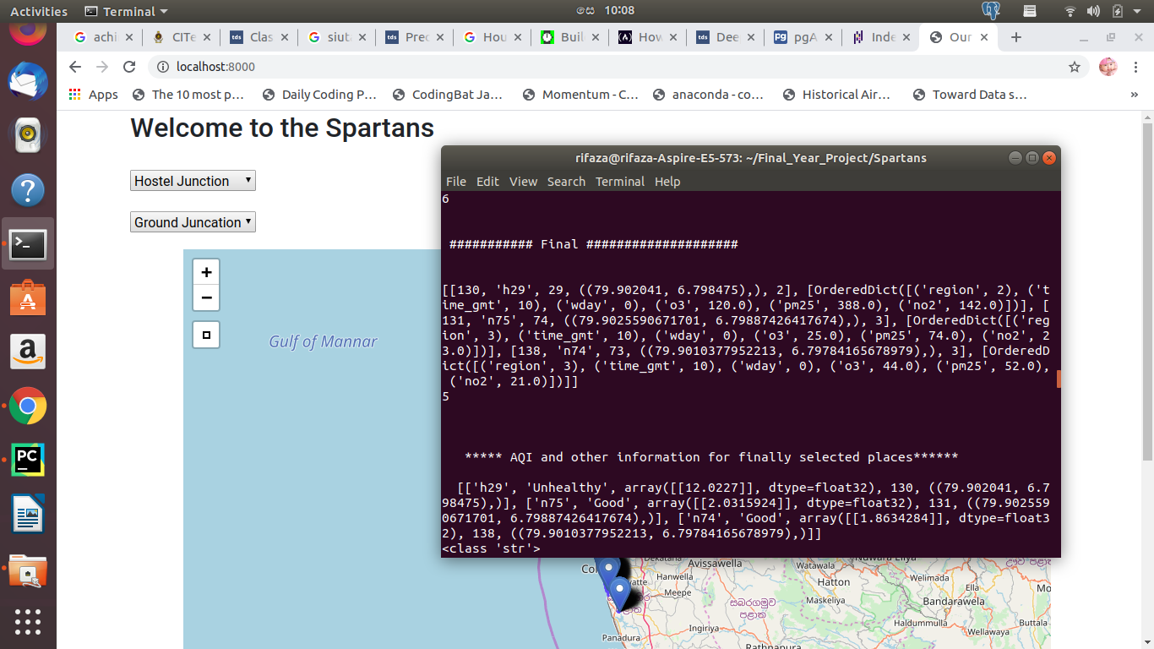

Figure 6.10: The relevant details of the certain place

According to the AQHI level, if there are many ‘Good’ AQI of Health level available, select the all ‘Good’ level places separately and find the distance between starting point and destination to select the shortest path among them by using the Dijkstra’s shortest path algorithm and short those paths.

Following figure shows the shortest path by using Dijkstra’s algorithm.

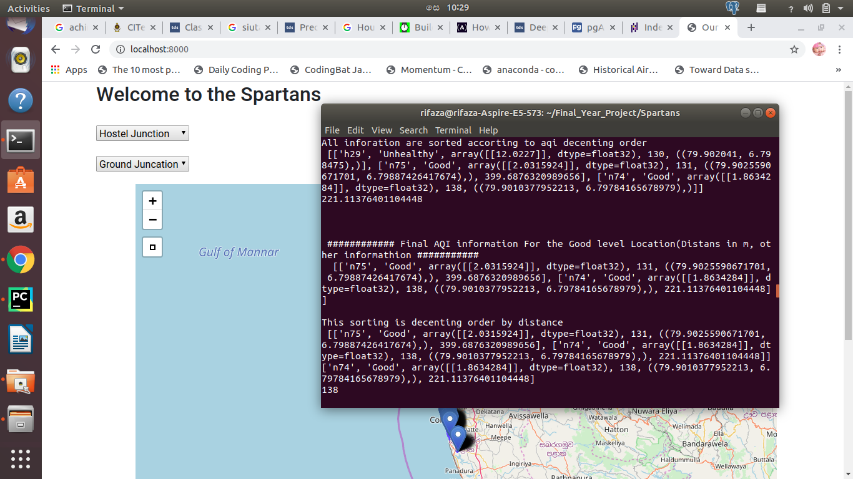

Figure 6.11: The AQHI and distance shorting

After that, select the shortest distance place among other all ‘Good’ levels. This is because we need to take the shortest route, considering the AQI's health status. After, find the road id for that place. For example here road _id 138 has 221.11 m distance, road _id 131 has 399.68 m distance. So selected as less distance place as a 221.11m (road_id = 138)

If AQHI level does not include the ‘Good’ level then we have to select the other health level order as follows: Good, Moderate, Unhealthy for Sensitive Groups [USG], Unhealthy, Very Unhealthy and Hazardous.

After path selected we have to select the starting and ending point of the selected road and compare those coordination with original starting point coordination to identify the original point among two points. After identify the original staring point assign the ending point of the selected route as new starting point. After that, compare the coordination of the new staring point to the original destination coordination.

If the comparison does not equal to the destination, then again we have to query the database to identify the connected road with that junction. We have to do same above process until the new starting point is to become the destination point. While this process we have to remove the selected road from the query result of connected road id because it prevents us to search backward.

Then finally, we will be having the all coordination of all selected paths starting and ending points. Using those coordination displays that path in the map.

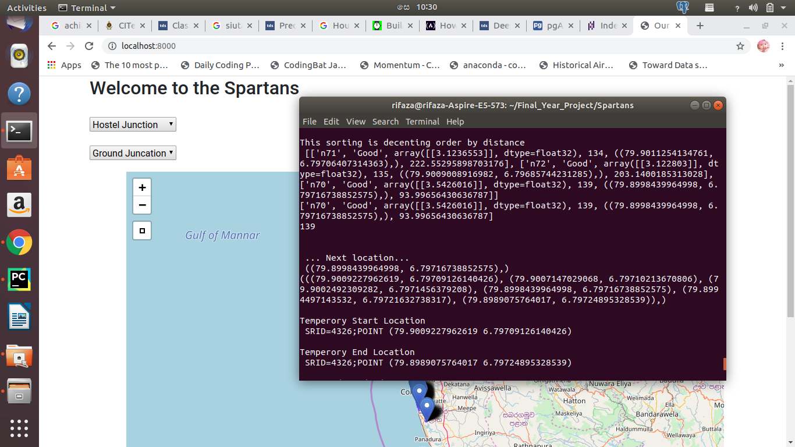

Figure 6.12: The shorting results and next location

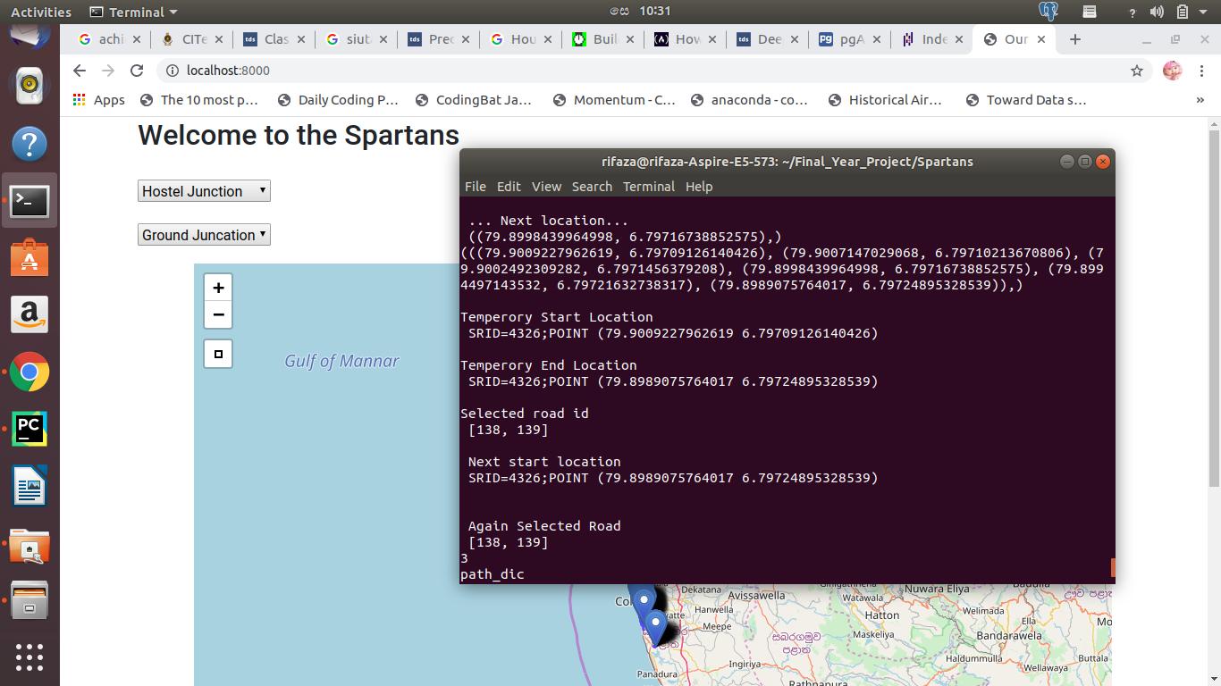

Figure 6.13: The selected road id

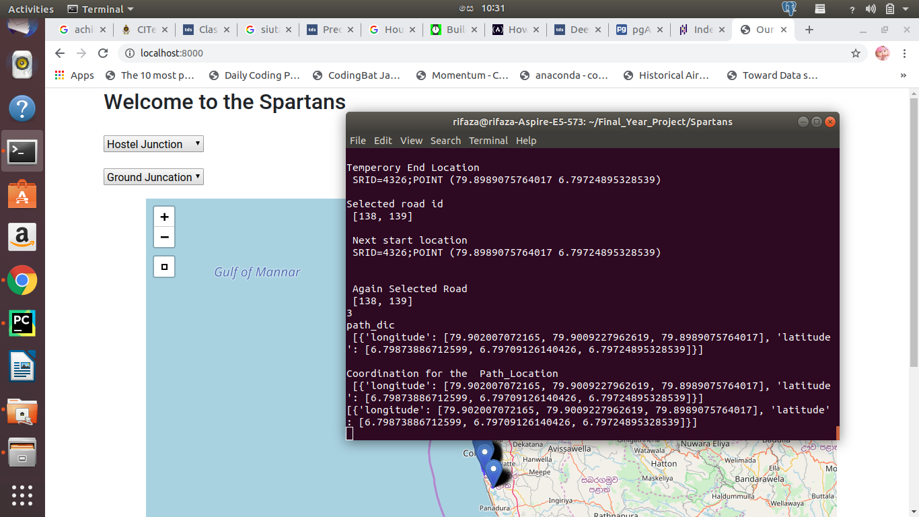

Figure 6.14 : The coordination for the path

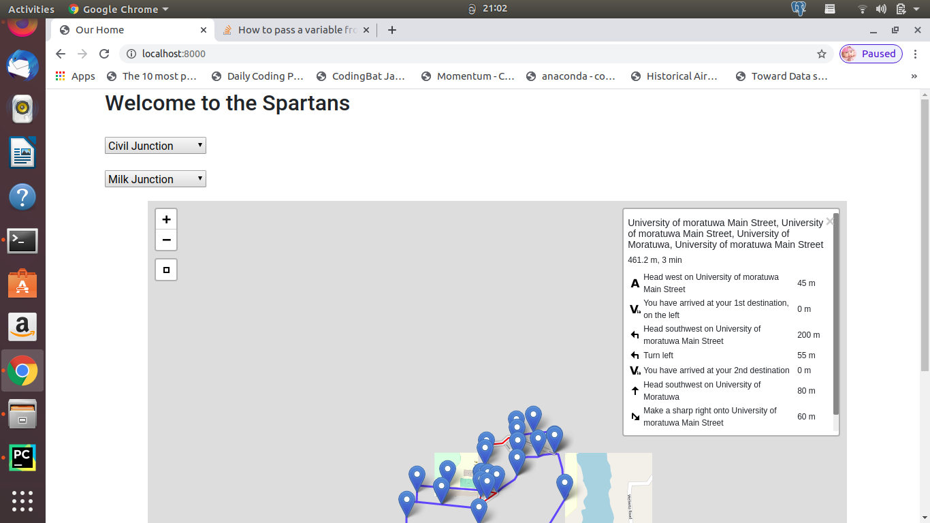

Figure 6.15 : The selected path

### Creating the customized map

Displaying the shortest path is the one of the important feature of the system. Considering the complexity in the current available map we decided to create the simplest customized map and we selected the two areas for that as follows: one is Colombo plan road with including the Galle road and Duplication road area and second one is inside the University of Moratuwa. For a testing currenty we use UOM map which we created.

This map has three region of the place as schools, hospitals, normal place and junctions. Here we used postgreSQL database to store those data in each separate tables and there is a separate table to with the details of Junction Vs. connected roads. We store relevant details manually.

We used Arc map to create customized map and after created, we checked with QGIS software whether the map has appropriate coordination. QGIS also one of the software which used to create customized map and display the maps.

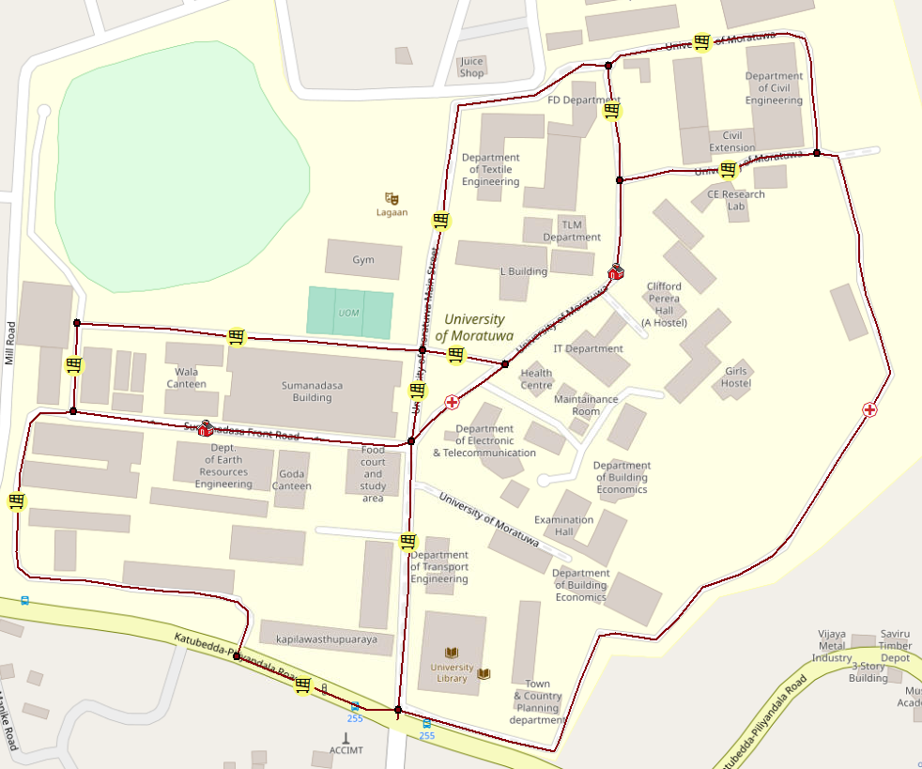

Figure 6.16 : The map of UOM

## Future simulation prediction

This module helps to user, if he wants to know about what is the AQHI level for coming next hours in a particular location. To find the future simulation the hospital place was selected. Using above module predicted AQHI hourly in that place. Then using that AQHI and AQHI changing rate was calculated. For that below equation was used.

Rate of change of AQI = (next hour AQI - present AQI)

Then AQHI changing rate was predicted using different model. Such as: Random Forest Regression, Decision Tree Regression and Deep NN. Then best model was selected by considering the less Mean Absolute Error. Decision Tree Regression model has less MAE. So it was selected. After that AQHI changing rate with time was displayed.

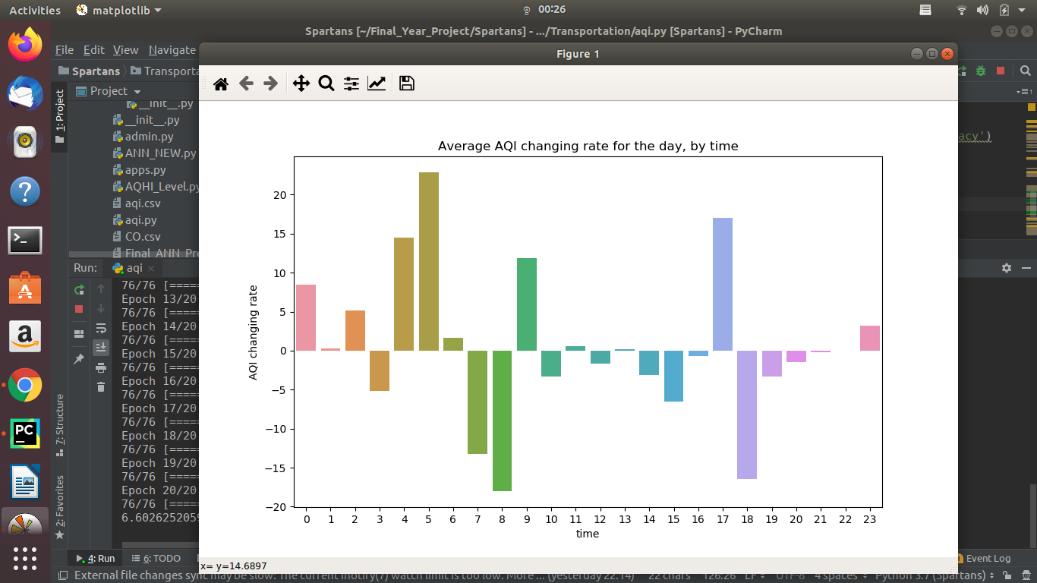

Figure 6.17 : The AQHI changing rate for the day

According to the graph we can get an idea about next hour’s AQI value using rate of change of AQHI in previous days for 24 hours.

If anyone wants to find the next hour AQI value for the given time he can find like. For example, If the time is 2.00pm and he has the present AQI value as 10, then using model he can predict the rate of change of AQHI value for time 2.00pm with AQHI value 10. If the rate of change is increase (positive value) for the next hour the AQHI value should be increased. Therefore we can suggest to user coming hour AQHI value is increasing and the AQHI level for that used a machine learning model to predict the next hours’ Health level of AQI.

For this model the inputs are time, AQI value, rate of change that we have already predicted and we calculate the next hour AQI value by adding rate of change to present AQI value. Because time is in hours. From the next hour’s AQHI value we can check for the AQHI level for the coming hour. All these are inputted to model and finally we can predict the level of AQHI level for the coming hour. From this predicted value we can give this information to user whether he can use this road for the coming hour or not. For this prediction again we used 3 machine learning model and choose the model that gave the highest accuracy. Decision tree classifier model gave the highest accuracy for this prediction.

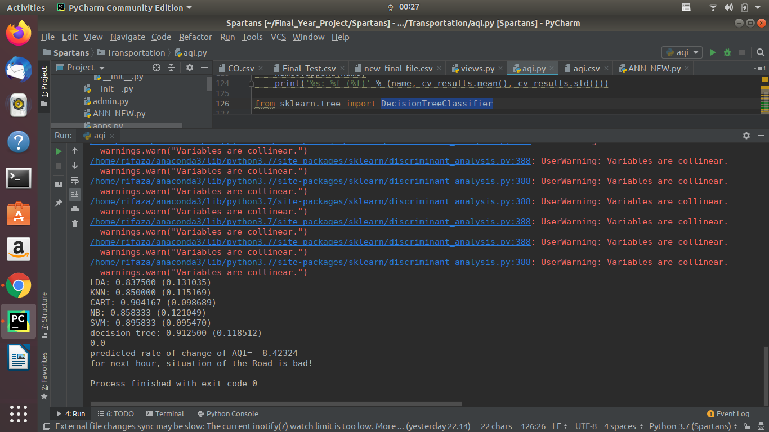

Figure 6.18 :The forecasted health level

## Summary

This chapter included details about how each modules of the system is implemented and the steps involved during the implementation of each sub modules and also the methods and approaches followed to implement them.

# 

**Evaluation**

## Introduction

This chapter provides in depth details of the implementation details and the testing performed on each module of the system and the results obtained through it are also explained. Evaluations of each module are explained in different sections.

## Evaluation Methods and Results

### AQI prediction models

Table 7.1:The evaluation details of AQHI prediction module

|  |  |  |  |
| --- | --- | --- | --- |
| Criteria | Description | Result | Comment |
| Input with current time, current date, Concentration of the NO2, O3, region id , and PM2.5, | Current day will calculate from the current date and if the current date is week days it will be ‘1’ otherwise it will be ‘0’.  Current hour will be calculated from the current time. | Correct AQHI with 0.003 mean absolute error | If the mean absolute error is less it means high accuracy. |
| Input with current time, day, region, High concentration for the O3, NO2, and high value of PM2.5 | If the concentration is high it will affect the Air pollution in drastically. So the AQHI should be high | Have got the high value for AQHI | There is direct relationship between the AQHI and concentration of the gases. Concentration of the gases affect the Air pollution |
| Testing the model accuracy with different type of the error criteria. Such as mean absolute error(MAE), mean squared error(MSE) | Finding the which type of error giving the less error value | When using the mean absolute error it giving the less error value like 0.003, 0.0043 | If the mean absolute error is less it means it has high accuracy. |
| Testing the input with day, time, region , concentration of the O3, NO2, PM25, NO | We don’t have ANY gas concentration in the training model. | Give the error for shape of the input is 6. Because we didn’t consider the value of ‘NO’ gas | The concentration of the NO gas does not include in the train model as an input feature. So there should be error |
| Testing the prediction of the AQHI is correct or not | The AQHI was predict  -ed then it was check  with AQHI which was  calculated using equa  -tion. | Both are approximately equal. | The model is predicting correctly |
| Testing the input with day as a string value and other input are correct numerical value. | Day should be 0 or 1. And it should be integer. | Give the error as ‘Wday’ is not string value | We can’t normalize the categorical value using the MinMax Scalar. So before predicting the AQHI there should be error. |
| Testing same input with different type of the model and finding the Mean Squared Error for different type of the model(Deep NN and Random forest Regression) | The model with less Mean Squared Error will be selected as a best model for the prediction. | Deep NN has less MSE. MSE is 0.00016 for the ANN.  The MSE for the Random forest Regression is 0.01797 | The Deep NN model was selected |



Figure 7.1:The mean squared error rate

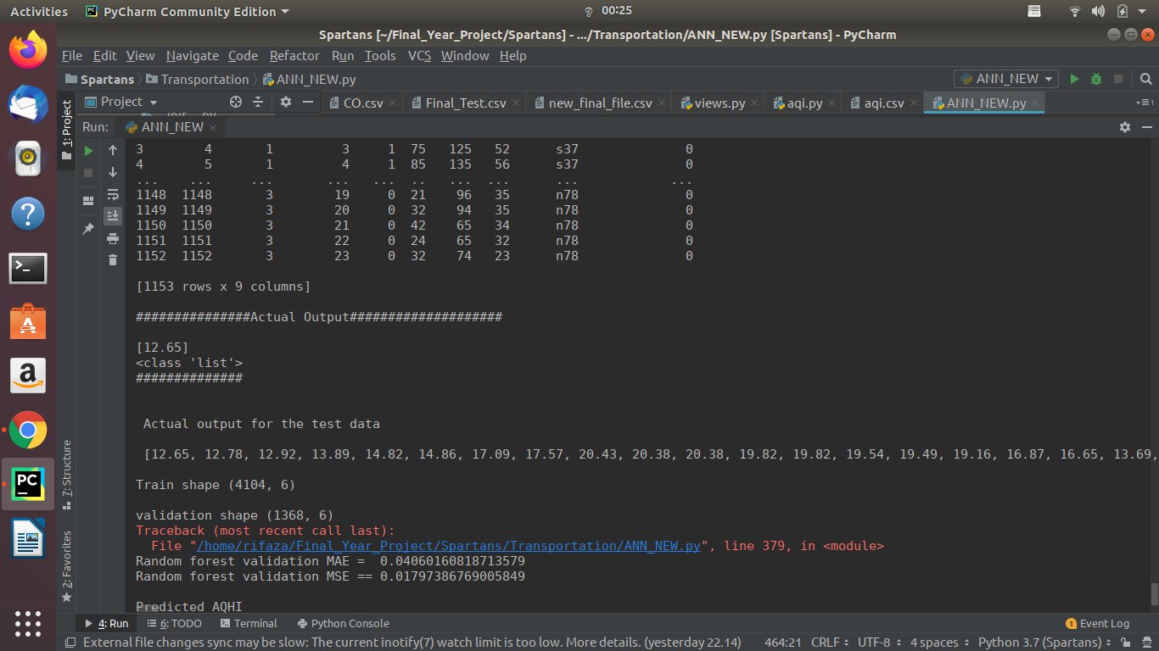

Figure 7.2:Validation of random forest

### Predicting AQI Health level model evaluation

Table 7.2:Evaluation details of AQHI health level predication module

|  |  |  |  |
| --- | --- | --- | --- |
| Criteria | Description | Output | Comment |
| Testing with time as 9.00 am for weekdays and region is 1and AQHI is 15.2 | AQHI for the school region threshold value is 15. If it less than 15 it will be ‘Moderate’. More than 15 is ‘unhealthy’ | The AQHI level is ‘unhealthy’ | The school is a sensitive place. If the AQHI high it will affect the Health of the student. So maintaining AQHI level in week days is very important |
| Testing the time as 9 value but the region should be 1, AQHI is 15.2 for week end days | AQHI for the school region threshold value for weekend days is 17. If it less than 17 it will be ‘Moderate’. More than 17 is ‘unhealthy’ | The AQHI level is ‘moderate’ | The weekend days threshold value is higher than the week days threshold value. So same AQI (15.2) will be consider for the moderate level in weekend days |
| Testing the time as 12 value but the region should be 2, AQHI is 15.2 | AQHI for the hospital region threshold value is 14. If it less than 14 it will be ‘Unhealthy’. More than 14 is ‘ Very unhealthy’ | The AQHI level is  ‘Very unhealthy’ | The hospital is a very sensitive place. If the AQHI high it will affect the Health of the patient. So maintaining AQHI level is very important |
| Testing the time as 12 value but the region should be 2, AQHI is 5.2 | AQHI for the hospital region threshold value is 6. If it less than 6 it will be ‘Good’. More than 14 is ‘ Very Moderate’ | The AQHI level is ‘Good’ | The hospital is a very sensitive place. Because of that the thresh hold for ‘Good’ level is less that other region. It is 6 for Hospitals but 10 and 14 for school and normal places respectively.  So maintaining AQHI level for hospital is very important |
| Testing same input with different type of the model and finding the Mean Absolute Error for different type of the model(Decision Tree classifier and Random forest Regression) | The model with less Mean Absolute Error will be selected as a best model for the prediction. | Decision tree has 0.0 MAE.  The MAE for the Random forest Regression is 0.00058 | The Decision Tree model was selected |
| Testing the prediction of the AQI health level is correct or not | The AQI health level was calculated using logic and same time using model. Both should be equal if the model is correct | Both are equal. So the model prediction is correct. | The model is predicting correctly. |

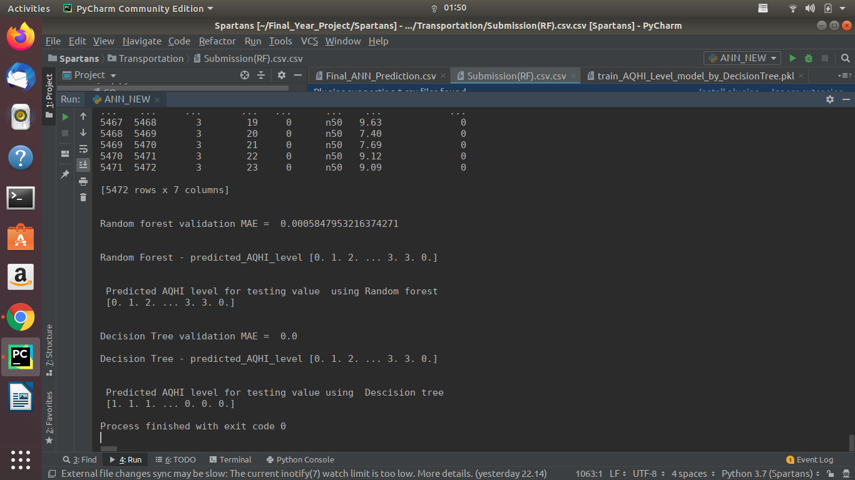

Figure 7.3: validation

### Identifying Optimized path module evaluation

Table 7.3:The evaluation details of optimized path module

|  |  |  |  |
| --- | --- | --- | --- |
| Criteria | Description | Output | Comment |
| Starting and destination places within the same road is tested(ex: Hostel junction to lagan junction) | There should be only one selected road for the optimized path | There is only one road is selected for the path. That was lagan road. | The optimized path was founded. |
| Starting and destination places selected and starting place connected road only has the normal places was tested | If the Health concern level are ‘Good’ then the lass distance should be consider to select the optimized route | The optimized route was selected with the less distance | If that Health concern level for the normal places are ‘Good’ then the distance between that place and destination place will be consider for the optimized path |
| Stating place connected road only include the hospital and school place was tested | Then if that places does not include the ‘Good’ level for the Health concern level then ‘Moderate’ level and then ‘Unhealthy’ level will be considered | The moderate level is selected for the optimized path | If there is no ‘Good’ level then the ‘moderate’ and after that ‘Unhealthy level’ should be considered |

### Future simulation prediction module evaluation

Table 7.4:The details of future simulation module

|  |  |  |  |
| --- | --- | --- | --- |
| Criteria | Description | Output | Comment |
| Future AQI Health level was predicted with the time 2.00 for the hospital place with Current AQHI as 10 | The AQHI changing rate for the particular place should be predicted and according to that AQHI changing rate AQHI and AQI health level was predicted for the coming hour | AQHI changing rate was positive value as +3 | So the AQHI for the future was increased. The AQHI for coming hour is 13. So the health level for AQI is unhealthy |
| Future AQI Health level was predicted with the time 23.00 for the hospital place with Current AQHI as 7 | The AQHI changing rate for the particular place should be predicted and according to that AQHI changing rate AQHI and AQI health level was predicted for the coming hour | AQHI changing rate was negative value as -1 | So the AQHI for the future was decreased. The AQHI for coming hour is 6. So the health level for AQI is ‘Good’ |

## Summary

In this chapter we discussed about the kind of evaluation has been performed to each three module and results of those modules. In next chapter we are going to discuss about the discussion of the work, conclusions and further work can be able to do in future.

# 

**Conclusion and Further Work**

## Introduction

In the previous section we discussed about interpretation of the individual modules in the system and how it implemented so far. This chapter gives a discussion about the inputs and outputs of the system and the assumptions made while implementing the system. Furthermore, the limitations of the current system are discussed and future developments, which will aid future of print embossed fabric defect detection, are also described in here.

## Discussion about the work

Traffic on roads has significantly increased in the Sri Lanka and elsewhere over the past 20 years. In many areas, vehicle emissions have become the dominant source of air pollution, including carbon monoxide (CO), carbon dioxide (CO2), volatile organic compounds (VOCs) or hydrocarbons (HCs), nitrogen oxides (NOx), and particulate matter (PM). The increasing severity and duration of traffic congestion have the potential to greatly increase pollutant emissions and to reduce air quality, particularly near large roadways. These emissions contribute to risks of morbidity and mortality for drivers, commuters and individuals living near roadways, as shown by epidemiological studies, evaluations of proposed vehicle emission standards, and environmental impact assessments for specific road projects [10]. Especially these emissions contribute to risks of morbidity and mortality for school students and patience. So here we are mainly focusing about the health of students and patience based on the air pollution and air quality due to the traffic. Therefore we are suggesting the different route for commuters to reduce the traffic emission by considering the air quality in the different route.

## Limitations and Further Work

In this project we proposed a system which able to reduce the air pollution in the certain place through directs the vehicle to other good region. By following this system we can reduce the air pollution especially near the hospitals area and school area and also we have future air quality prediction module which tells the user to health level of the air on the certain place for next hours.

We used samples data for this project due to the lack of data resources. In future, this work can be able to do for dynamic data and it will be able to use in the future world to reduce the air pollution.

## Conclusion

This project work focused on automating the optimized route for the commuters who are using the Map for finding the traffic related information. A system is proposed with deep touch of machine learning and neural network and GIS.

## Summary

In this chapter discuss about the inputs, outputs, assumptions that was used during the implementation. It also gave an understanding about the scope of the research with its limitations and future developments of the system. Next chapter will include a list of references used in development of the system.

# 

**Reference**

[1] A Kumar, P Goyal, Air quality prediction of PM10 through analytical dispersion model for Delhi. Aerosol Air Qual. Res. 14(5), 1487–1499 (2014)

[2] A-L Dutot, J Rynkiewicz, FE Steiner, J Rude, A 24-h forecast of ozone peaks and exceedance levels using neural classifiers and weather predictions. Environ. Model Softw. 22, 1261–1269 (2007)

[3] Anon, (2019). [ebook] Available at: https://www.ncbi.nlm.nih.gov/pmc/articles/PMC4243514/ [Accessed 6 Sep. 2019].

[4] Balali-Mood, M., Ghorani-Azam, A. and Riahi-Zanjani, B. (2016). Effects of air pollution on human health and practical measures for prevention in Iran. *Journal of Research in Medical Sciences*, 21(1), p.65.

[5] Beijing Municipal Environmental Monitoring Center. Available online: www.bjmemc.com.cn (accessed on 9 September 2019).

[6] Chen, H. and Copes, R. (2012). Review of Air Quality Index and Air Quality Health Index. *Epidemiology*, 23, p.219.

[7] China Ministry of Environmental Protection. Ambient Air Quality Standards. GB 3095-2012; China Environmental Science Press: Beijing, China, 2012.

[8] De Vito, S.; Fattoruso, G.; Pardo, M.; Tortorella, F.; Di Francia, G. Semi-supervised learning techniques in

artificial olfaction: A novel approach to classification problems and drift counteraction. IEEE Sens. J. **2012**, 12, 3215–3224. [CrossRef]

[9] De Vito, S.; Massera, E.; Piga, M.; Martinotto, L.; Di Francia, G. On field calibration of an electronic nose

for benzene estimation in an urban pollution monitoring scenario. Sens. Actuators B **2008**, 129, 750–757. [CrossRef]

[10] De Vito, S.; Piga, M.; Martinotto, L.; Di Francia, G. CO, NO2 and NOX urban pollution monitoring with

on-field calibrated electronic nose by automatic bayesian regularization. Sens. Actuators B **2009**, 143, 182–191. [CrossRef]

[11] Environmentlaw.org.uk. (2019). Air Pollution - Road Traffic. [online] Available at: http://www.environmentlaw.org.uk/rte.asp?id=38 [Accessed 5 Sep. 2019].

[12] H. F. X. L. Jiansheng Liu, "Combination Prediction for Short-term Traffic Flow Based," pp. 1-5, 2006.

[13] Khanna, A. (2018). Intelligent Traffic Management System for Smart Cities. [online] Melbourne, Australia: Researchgate. Available at: https://www.researchgate.net/publication/323549873 [Accessed 5 Sep. 2019].

[14] Leo, B. Random forests. Mach. Learn. **2001**, 45, 5–32.

[15] Library, W. P. (2013). Ministry of Environmental Protection of the people's Republic of China.

[16] Lin, Y., Zhao, L., Li, H. and Sun, Y. (2018). Air quality forecasting based on cloud model granulation. EURASIP Journal on Wireless Communications and Networking, 2018(1).

[17] Liu, H.; Li, Q.; Yan, B.; Zhang, L.; Gu, Y. Bionic Electronic Nose Based on MOS Sensors Array and Machine Learning Algorithms Used for Wine Properties Detection. Sensors 2019, 19, 45. [CrossRef] [PubMed]

[18] Liu, H., Li, Q., Yu, D. and Gu, Y. (2019). Air Quality Index and Air Pollutant Concentration Prediction Based on Machine Learning Algorithms. Applied Sciences, 9(19), p.4069.

[19] M El-Harbawi, Air quality modelling, simulation, and computational

methods: A review. Environ. Rev. 21, 149–179 (2013)

[20] N Haizum, A Rahman, MH Lee, MT Latif, Artificial neural networks and fuzzy

time series forecasting: An application to air quality. Qual. Quant. 49, 2633(2015)

[21] P Hajek, Predicting common air quality index—The case of Czech microregions. Aerosol Air Qual. Res. 15(2), 544–555 (2015)

[22] P Hájek, V Olej, Ozone prediction on the basis of neural networks, support vector regression and methods with uncertainty. Ecol. inform. 12, 31–42 (2012)

[23] Sheng, N.; Tang, U.W. The first o_cial city ranking by air quality in China—A review and analysis. Cities **2016**, 51, 139–149. [CrossRef]

[24] Who.int. (2020). *Air pollution*. [online] Available at: https://www.who.int/health-topics/air-pollution#tab=tab_1 [Accessed 26 Feb. 2020].

[25] W. Yu, "Traffic Prediction Method Based on RBF Neural Network with Improved Artificial Bee Colony Algorithm," 2015

[26] Zhang, Q.; Jiang, X.; Tong, D.; Davis, S.J.; Zhao, H.; Geng, G.; Feng, T.; Zhang, B.; Lu, Z.; Streets, D.G.; et al. Transboundary health impacts of transported global air pollution and international trade. Nature 201**7**, 543, 705. [CrossRef] [PubMed]

[27] Zhu, S.; Lian, X.; Liu, H.; Hu, J.; Wang, Y.; Che, J. Daily air quality index forecasting with hybrid models: A case in China. Environ. Pollut. **2017**, 231, 1232–1244. [CrossRef]

28<https://www.programiz.com/python-programming>

[29<https://www.forbes.com/sites/bernardmarr/2018/09/24/what-are-artificial-neural-networks-a-simple-explanation-for-absolutely-anyone/#52939aab1245>

[30]<https://en.wikipedia.org/wiki/ArcMap>

31 <https://realpython.com/location-based-app-with-geodjango-tutorial/#setting-up-your-project>

32<https://www.epa.gov/>

33] <https://forum.airnowtech.org/t/aqi-calculations-overview-ozone-pm2-5-and-pm10/168>

34 <https://www.displayr.com/what-is-a-correlation-matrix/>

**Appendix – A**

**Individual Contribution to the Project**

**Name of the student: AF. Rifaza [154203E]**

As a member of Spartans my contribution in this project was on understanding about the Air quality Health Index (AQHI) and predicting the AQHI for particular place by using Deep Neural Network. Predict the level of health concern for particular AQHI by using Decision Tree Classifier. Initially I had zero knowledge on traffic management. Then I went through related theses about traffic management and air pollution and analyzed different features of the environment that are mostly related to the traffic. Then I understood about AQI and AQHI then understood about how they forecasting the pollution index for the pollutant using different model. Importantly, NN is used to predict air quality. Then I want to find the exact method for finding AQHI for different gas concentration and other features. For that I went through certain articles and papers to understand about appropriate function that need to find the AQHI using different calculation way. Then I found that NN and Random Forest Regression are the suitable models for to predict the AQHI. Then I reviewed the neural network techniques and Random forest Technique to find the approach that better fits our problem. Then I construct deep neural network and random forest model with suitable hyper parameters. Selected best model for the problem by considering the Mean Squared Error (MSE). Because, it was a Regression Problem. Finally I selected Deep Neural network is a best model for the Prediction of AQHI.

After that I went through the review papers and found the relationship between AQHI and Health level of AQI. There is a standard category for the AQI such as good, moderate, unhealthy, very unhealthy, etc. But here we assumed that this AQI values for the categories are different to region to region. Based on the region and date and time we divided the categories differently. Then predict the AQI Health level for particular place using Decision Tree and Random forest classifier. Finally I select the Decision Tree Classifier as a best model to predict the Heath concern level for particular place.

After that created GIS database with PostgreSQL and PostGIS to get benefit from the spatial features. Then used the GeoDjango sub framework to implement geo location features in the application. And Initially get the starting location from the users and Found the connected roads for that starting location using queries and . Then identified the available places in each roads and fount the region of that places. Then got the concentration and other details information for that place using queries. After that I predicted the AQHI for those places using Deep Neural Networks and Predicted AQHI Health level for those places. Also I evaluated the AQHI and AQHI health level by using equation. As per the objectives I have successfully predicted AQHI and AQI health level for the places within each route.

**Name of the student: M.M.F Arzana [154007G]**

My individual part is finding the optimal direction. This module helps users to find out the best optimized path with in good health level. First of all, I studied about ArcGIS to create the customized map because one of the features of the system is display the optimized path to the user. For that I got decided to create a simplified customized map. For this purpose I used Arc Map software and I used open street map with coordination as follow: “WGS_1984_Web_Mercator_Auxiliary_Sphere” and I marked one place per road and I got created database and it has separate tables for schools, hospitals, normal place, junctions and roads included with longitude, latitude, Id and name and it has separate table with details of junction with the connected roads.

After that, I started work on to create the optimal direction module. To work on GIS application was very new to me and I did not know anything about that. So I start to learn about postgreSQL which is the open source relational database which support to the geographical feature, GeoDjango which is the python frame work to implement geo locational feature.

Initially I got the one starting point and I was marked initial point as one of junction and I got the road IDs of connected road and I identify the places in those roads by querying. After that, I was able to get the predicted AQHI health level for those places from previous module and first selected the good levels. If more the good levels available then, I calculated the distance between the starting point and destination point and short the distance and selected the least distance path as optimal road. After that, find the starting and ending point of the road and compared with the original starting point to identify which was the initial starting point. Then select the ending point as the new starting point and compared its geo coordinate with destination’s geo coordinates. If above coordinated not equal then I continued that same process until it became equal.

In other scenario during the identifying the predicted AQHI level, I did not get good level. For that what I did is I choose the next above level of good [Moderate, like that] and continued the above process.

Apart from that, I was working with data generating process for long term because; in our project dataset was the very important thing.

**Name of the student: M.K.M.A.Arshan [154006D]**

My individual part is future simulation prediction. To find the future AQHI level, I selected the hospital region as my data house and in training dataset each hospital has data for 24 hours in hourly manner and corresponding AQHI values for previous week. After that I calculated the rate of change in AQHI using above mentioned equation in the module description. From this I was able to find the AQHI changing for next hours of previous week.

Then I selected previous day hourly AQHI values and trained and predict rate of change of AQHI over 24 hours.

After that I used time, AQHI, rate of change as input I predict the next future hour AQHI health level by adding rate of change to present AQHI. For this again I used three machine learning models as follows: ANN, Decision tree and Random forest regression. After that I selected the best model by considering the mean absolute error. Here I have selected decision tree as a best model. After all I plotted the graph between AQHI changing rate and time for 24 hours. Predicted the next hour of AQHI level over current time and value of current AQHI.

I got y=ax^2+bx+c, and for previous week also I got the same curve. So equally all days rate of change of AQHI over time was as the above mentioned graph.